PROPERTY MANAGEMENT SYSTEM



Submitted by : AKSHAY GUDELLI

Date of Submission: 10th July 2020.

Submitted to :Cyberace Infovision

Under the Guidance of : Junaid Khateeb (Director, Khateeb Insitute of Technical Education)

**Certificate Of completion**

## This is to certify that , Mr AKSHAY GUDELLI has successfully implemented an application PROPERY MANAGEMENT SYSTEM

**The Application has been accepted as a completed project as it meets all the requirements specified.**

**12th July 2020**

**(Khateeb Institute of Technical Education)**

**Acknowledgements :**

We owe our gratitude to many people who have supported us throughout this journey.

We would, firstly like to express our heartfelt gratitude towards our respected Principal Dr. M.D. Patil and our Head of Department Dr. Ashish Jadhav for providing us immense facilities, guidance and never-ending support.

The completion of any inter-disciplinary project depends upon cooperation and combined efforts of several sources of knowledge. We take this opportunity to express our profound gratitude and deep regards to our guide Mr. Madhav Vyas for his exemplary guidance, monitoring and constant encouragement throughout the course of this project.

Lastly, we thank our parents, family, friends and well-wishers who always looked for the chance to help us in whatever means came forth and for their constant encouragement without which the project would not be a distant reality.

**Table of Contents**

|  |  |
| --- | --- |
| **SUB-TOPIC** | **PG**  **NO** |
| **SYSTEM REQUIREMENT SPECIFICATIONS** | **7** |
| **TECHNOLOGY USED** | **8** |
| **DATA PROVIDED BY CLIENT** | **10** |
| **CODE AND OUTPUT**   * **LOGIN WINDOW** * **AGENTS** * **COMPANY** * **ORDERS** * **CUSTOMERS** * **BALANCE REPORT** * **COMPANY INSIGHTS** * **MAXIMUM REGISTERED CUSTOMERS** * **TIME SERIES** * **VIEWPOINT** | **13**  **17**  **20**  **21**  **23**  **27**  **29**  **36**  **39**  **40** |
| **TESTING**   * **COMPANY VALIDATION** * **ORDER VALIDATION** * **CUSTOMER VALIDATION** * **AGENT VALIDATION** | **41**  **42**  **44**  **46** |
| **ORDER-LOOKUP** | **49** |

Section 1 :

System Requirement Specifications

We were given the System Requirement Specifications (SRS). It was as follows: Sunville Properties is a Colorado based property consultant who have appointed their agents across Major Cities across the globe. They have sub-Companies which take care the business in different countries and are placed in the countries from where they operate from. The Company currently has been using multiple forms of data storage and want to streamline their working using an application, which can help them seamlessly navigate via different forms of storage. The company expected certain modules which needed to ne introduced in the system. Some of them are as follows:

1. A Visual Interface to add the data into each of their tables. A login authentication is mandatory for anyone to be able to modify the data.
2. Generate a report that highlights the balance amounts for all orders in descending order. Do mention the name and code of the agent handling the order. This information needs to be updated in the database .

The company also required some insights which were to be done in the project. Some of them are as follows:

1) On selection of the year, system should help them get the following

a) The total property area sold vs total property are leased in Sq.-m only.

b) Of the years 2017,2018,2019- which year got maximum leased area in CA and WS countries.

c) What are the Agent codes of all the agents who have got deals in ‘OWNED’ categories across the years.

These were the System Required Specifications for the project.

Section 2 :

Technology used

We used various technologies which included the following:

Python :

Python is an interpreted, high-level, general-purpose programming language. Created by Guido van Rossum and first released in 1991, Python's design philosophy emphasizes code readability with its notable use of significant whitespace. Its language constructs and object-oriented approach aim to help programmers write clear, logical code for small and large-scale projects.

**Below are some facts about Python Programming Language:**

1. **Python is currently the most widely used multi-purpose, high-level programming language.**
2. **Python allows programming in Object-Oriented and Procedural paradigms.**
3. **Python programs generally are smaller than other programming languages like Java. Programmers have to type relatively less and indentation requirement of the language, makes them readable all the time.**
4. **Python language is being used by almost all tech-giant companies like – Google, Amazon, Facebook, Instagram, Dropbox, Uber… etc.**
5. **The biggest strength of Python is huge collection of standard library which can be used for the following:**
   * **Machine Learning**
   * **GUI Applications (like  Tkinter, PyQt etc. )**
   * **Web frameworks like Django (used by YouTube, Instagram, Dropbox)**
   * **Image processing (like OpenCV, Pillow)**
   * **Web scraping (like Scrapy, BeautifulSoup, Selenium)**
   * **Test frameworks**
   * **Multimedia**
   * **Scientific computing**
   * **Text processing and many more.**

**In other programming languages like C, C++, and Java, you will need to declare the type of variables but in Python you don’t need to do that. Just type in the variable and when values will be given to it, then it will automatically know whether the value given would be an int, float, or char or even a String.**

**The following is a basic program to explain how python works:**

**# Python code for "Hello World"**

**#code begins**

**print("Hello World")**

**#code ends**

**Output : Hello World**

**Tkinter:**

**Python offers multiple options for developing GUI (Graphical User Interface). Out of all the GUI methods, tkinter is the most commonly used method. It is a standard Python interface to the Tk GUI toolkit shipped with Python. Python with tkinter is the fastest and easiest way to create the GUI applications. Creating a GUI using tkinter is an easy task.  
To create a tkinter app:**

1. **Importing the module – tkinter**
2. **Create the main window (container)**
3. **Add any number of widgets to the main window**
4. **Apply the event Trigger on the widgets.**

**Importing tkinter is same as importing any other module in the Python code. Note that the name of the module in Python 2.x is ‘Tkinter’ and in Python 3.x it is ‘tkinter’.**

**import tkinter**

**There are two main methods used which the user needs to remember while creating the Python application with GUI.**

1. **Tk(screenName=None,  baseName=None,  className=’Tk’,  useTk=1): To create a main window, tkinter offers a method ‘Tk(screenName=None,  baseName=None,  className=’Tk’,  useTk=1)’. To change the name of the window, you can change the className to the desired one. The basic code used to create the main window of the application is:**

**m=tkinter.Tk() where m is the name of the main window object**

1. **mainloop(): There is a method known by the name mainloop() is used when your application is ready to run. mainloop() is an infinite loop used to run the application, wait for an event to occur and process the event as long as the window is not closed.**

**m.mainloop()**

|  |
| --- |
|  |

**tkinter also offers access to the geometric configuration of the widgets which can organize the widgets in the parent windows. There are mainly three geometry manager classes class.**

1. **pack() method:It organizes the widgets in blocks before placing in the parent widget.**
2. **grid() method:It organizes the widgets in grid (table-like structure) before placing in the parent widget.**
3. **place() method:It organizes the widgets by placing them on specific positions directed by the program.**

**MySQL:**

**MySQL** **server is a open-source relational database management system which is a major support for web based applications. Databases and related tables are the main component of many websites and applications as the data is stored and exchanged over the web. Even all social networking websites mainly Facebook, Twitter and Google depends on MySQL data which are designed and optimized for such purpose. For all these reasons, MySQL server becomes the default choice for web applications.**

**MySQL server is used for data operations like querying, sorting, filtering, grouping, modifying and joining the tables. Before learning the commonly used queries, let us look into some of the advantages of MySQL.**

**Advantages of MySQL :**

* **Fast and high performance database.**
* **Easy to use, maintain and administer.**
* **Easily available and maintain integrity of database.**
* **Provides scalability, usability and reliability.**
* **Low cost hardware.**
* **MySQL can read simple and complex queries and write operations.**
* **InnoDB is default and widely used storage engine.**
* **Provides strong indexing support.**
* **Provides SSL support for secured connections.**
* **Provides powerful data encryption and accuracy.**
* **Provides Cross platform compatibility.**
* **Provides minimized code repetition.**

**Queries can be understood as the commands which interacts with database tables to work around with data.**

**You need to know the following detail of the MySQL server to perform the connection from Python.**

* **Username –  i.e., the username that you use to work with MySQL Server. The default username for the MySQL database is a root**
* **Password – Password is given by the user at the time of installing the MySQL database. If you are using root, then you won’t need the password.**
* **Host Name – is the server name or Ip address on which MySQL is running. if you are running on localhost, then you can use localhost, or it’s IP, i.e. 127.0.0.0**
* **Database Name – Database name to which you want to connect.**

Section 3 :

The Database which we had consisted of 4 columns (agents,company,customer,orders).

The client has provided some rows in each of the table as shown below:

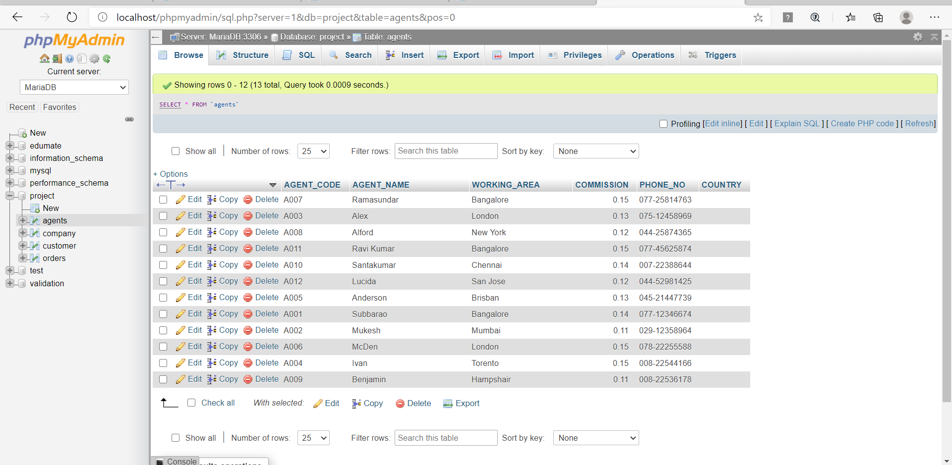

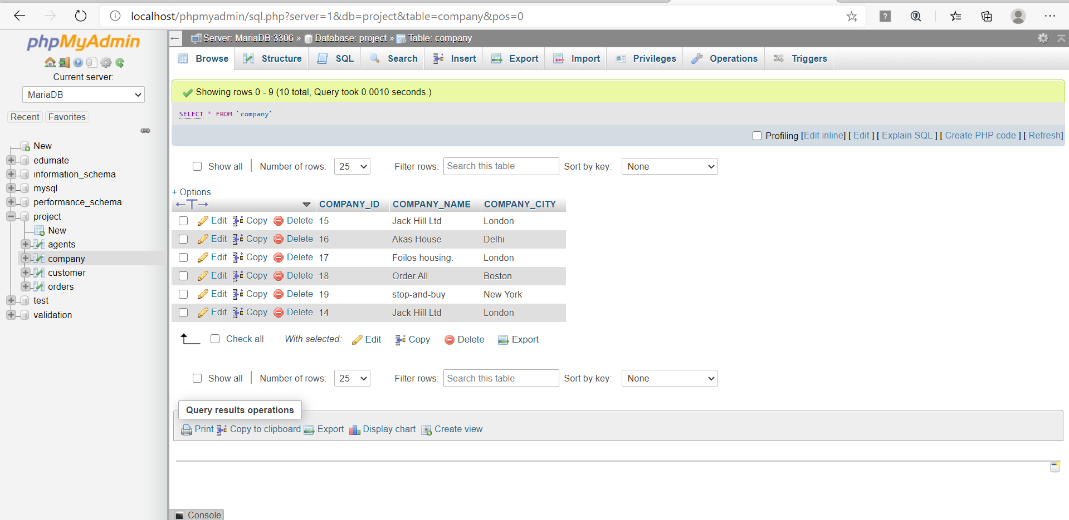

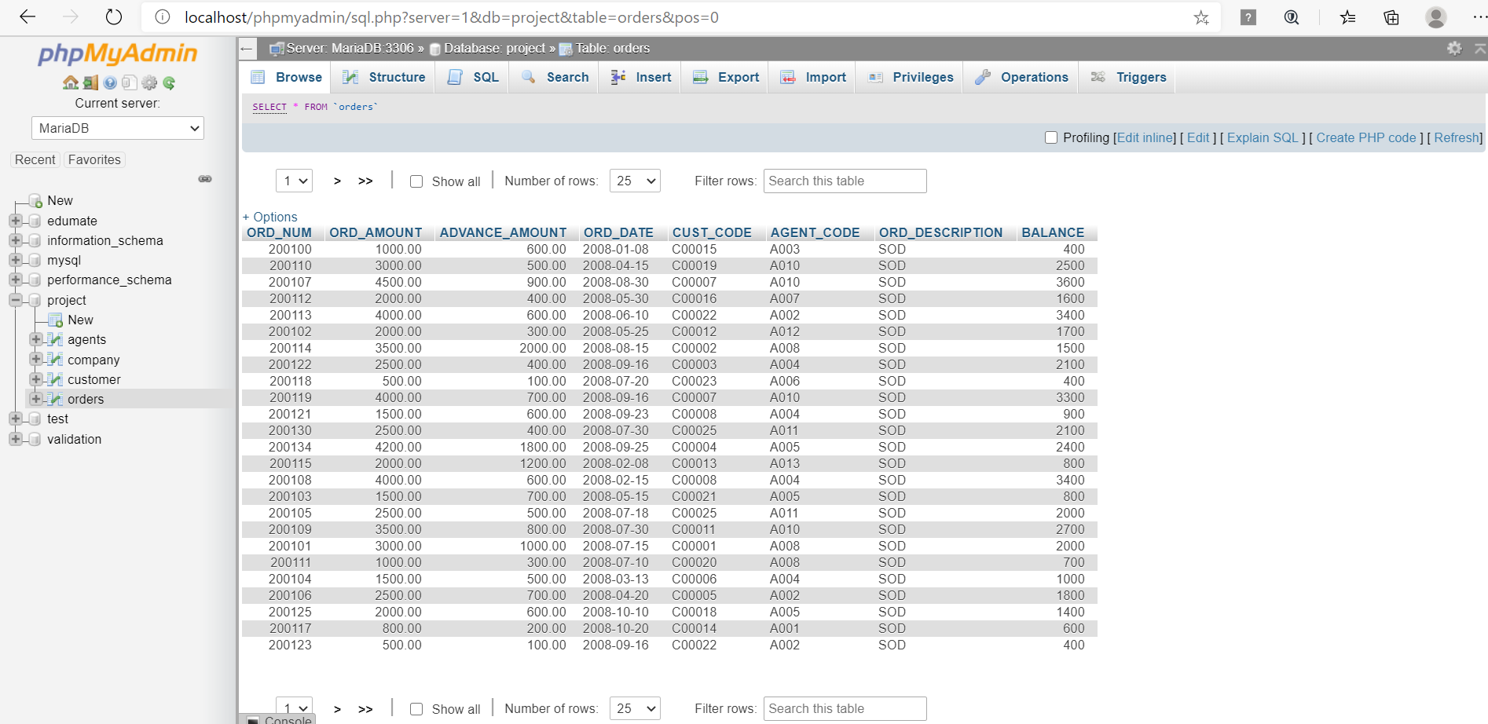

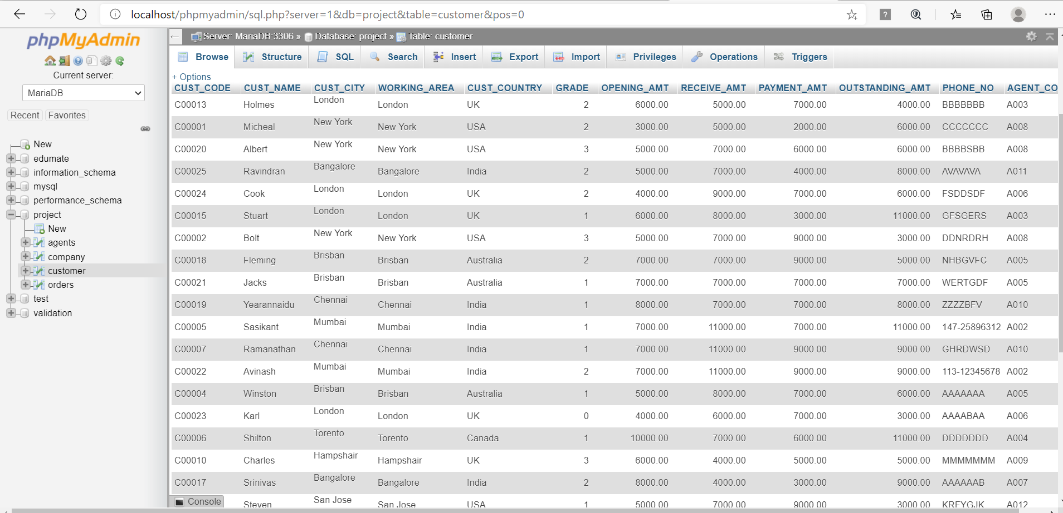

The company has also provided the data which included owned and leased property of the customers. It includes 1204 rows and 13 columns. The dataset is as follows:

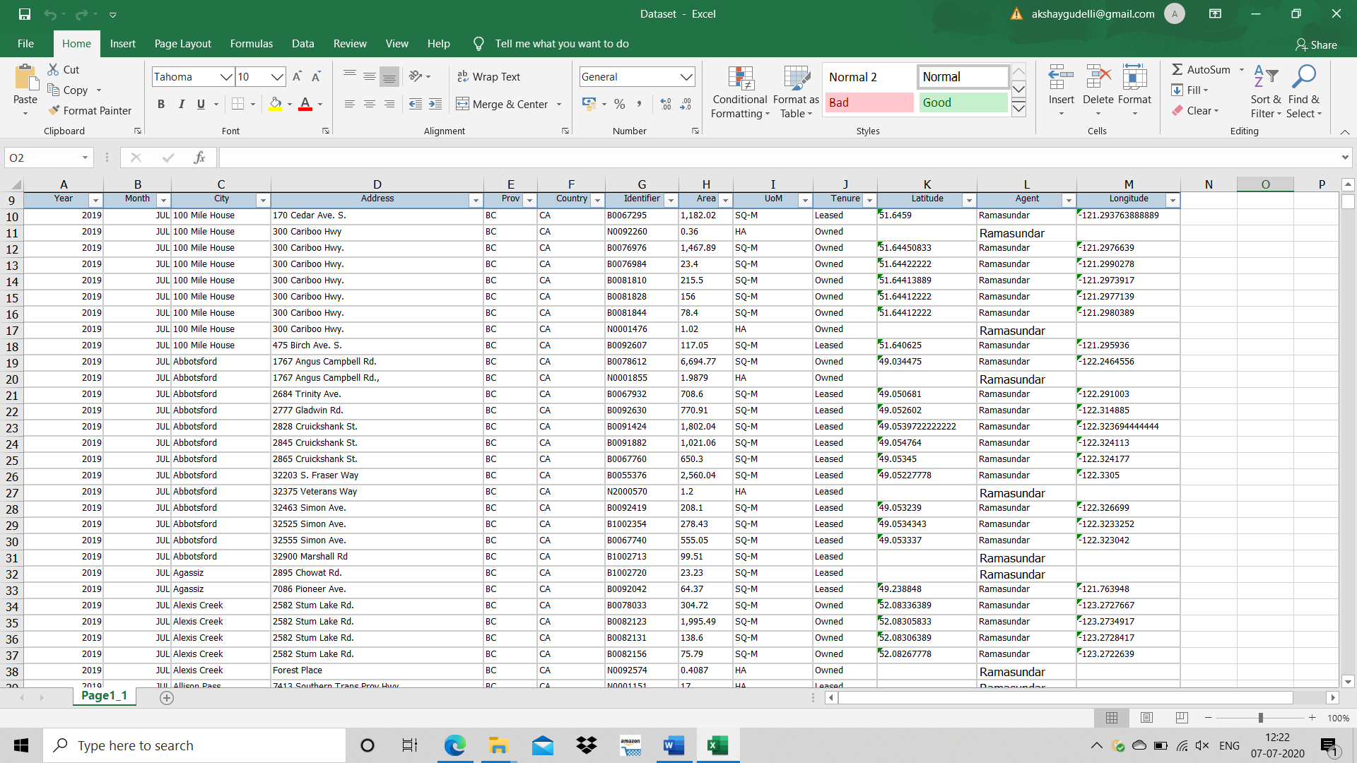

We used MySQL for the database and WAMP server.

Section 4:

This function is used for adjusting the window size and making the necessary configuration on start of window

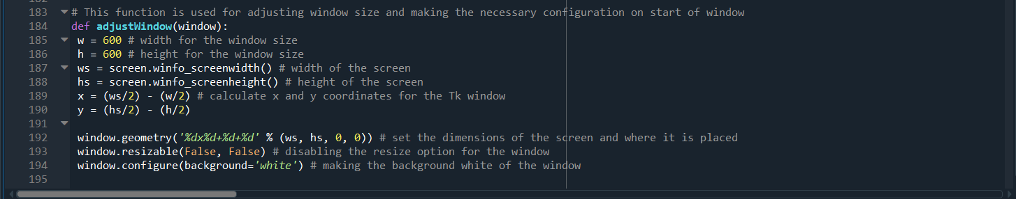

The main_screen function displays the first page and login_verify_company function verifies the login details

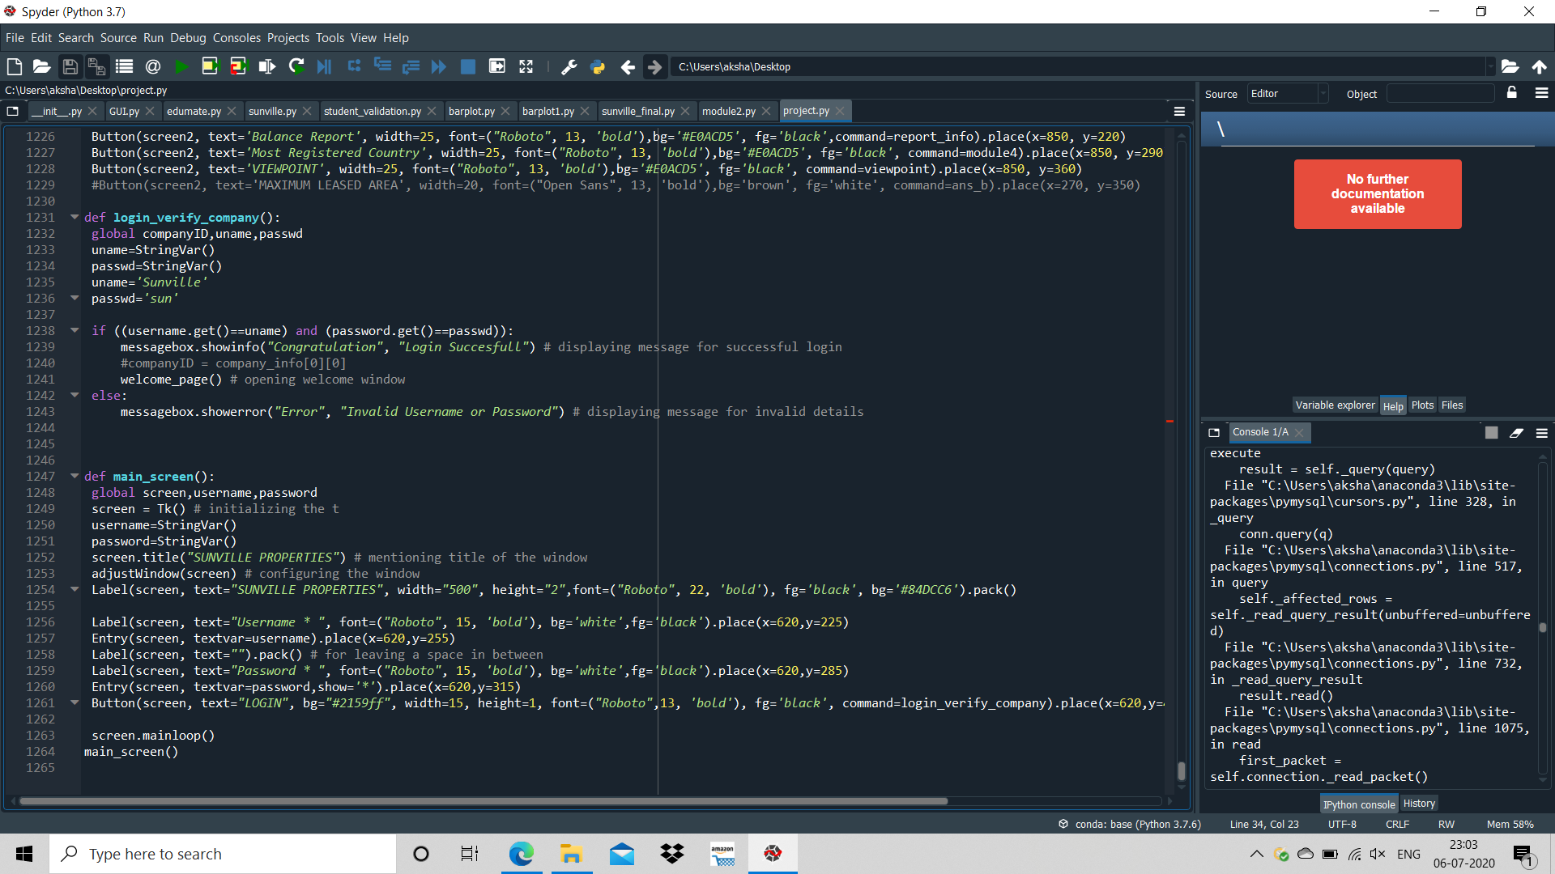

If login details are entered incorrectly it displays an error

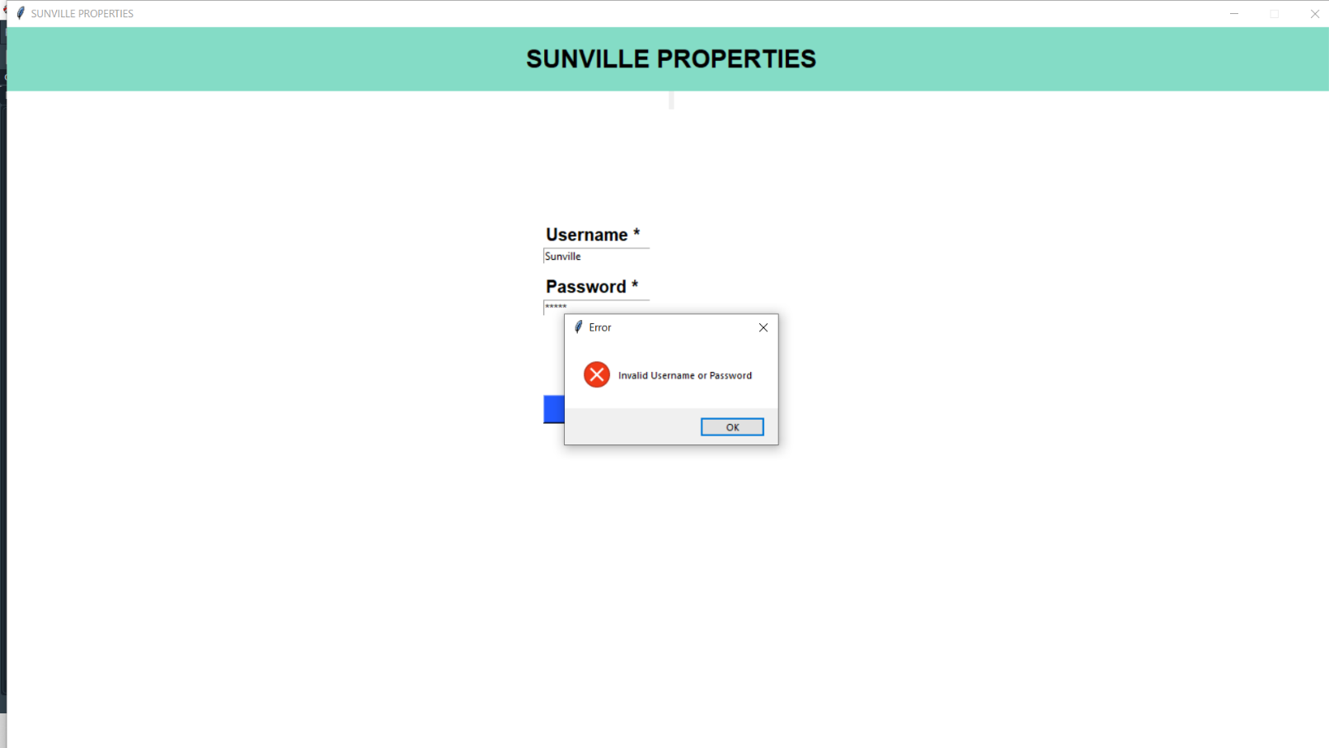

When logged in using correct login details

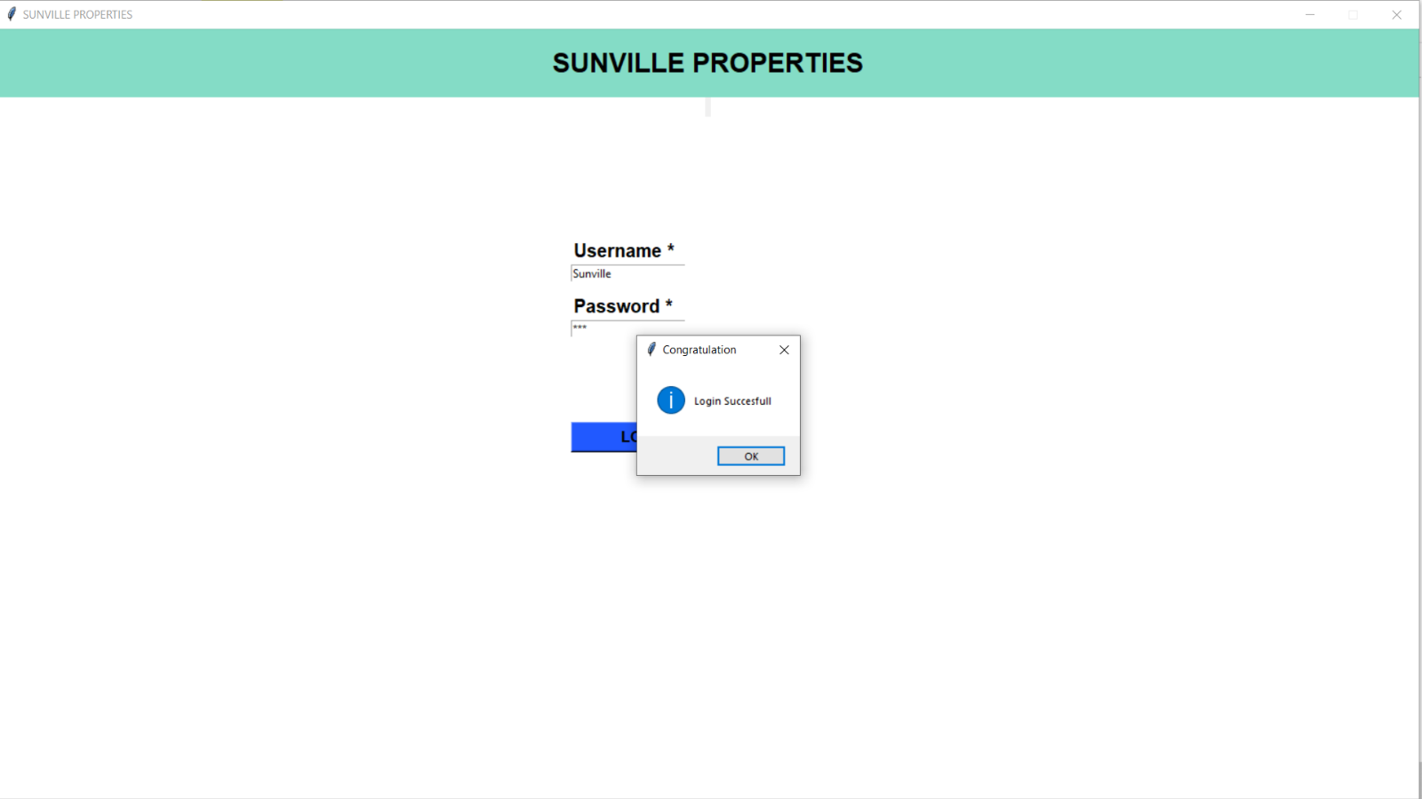

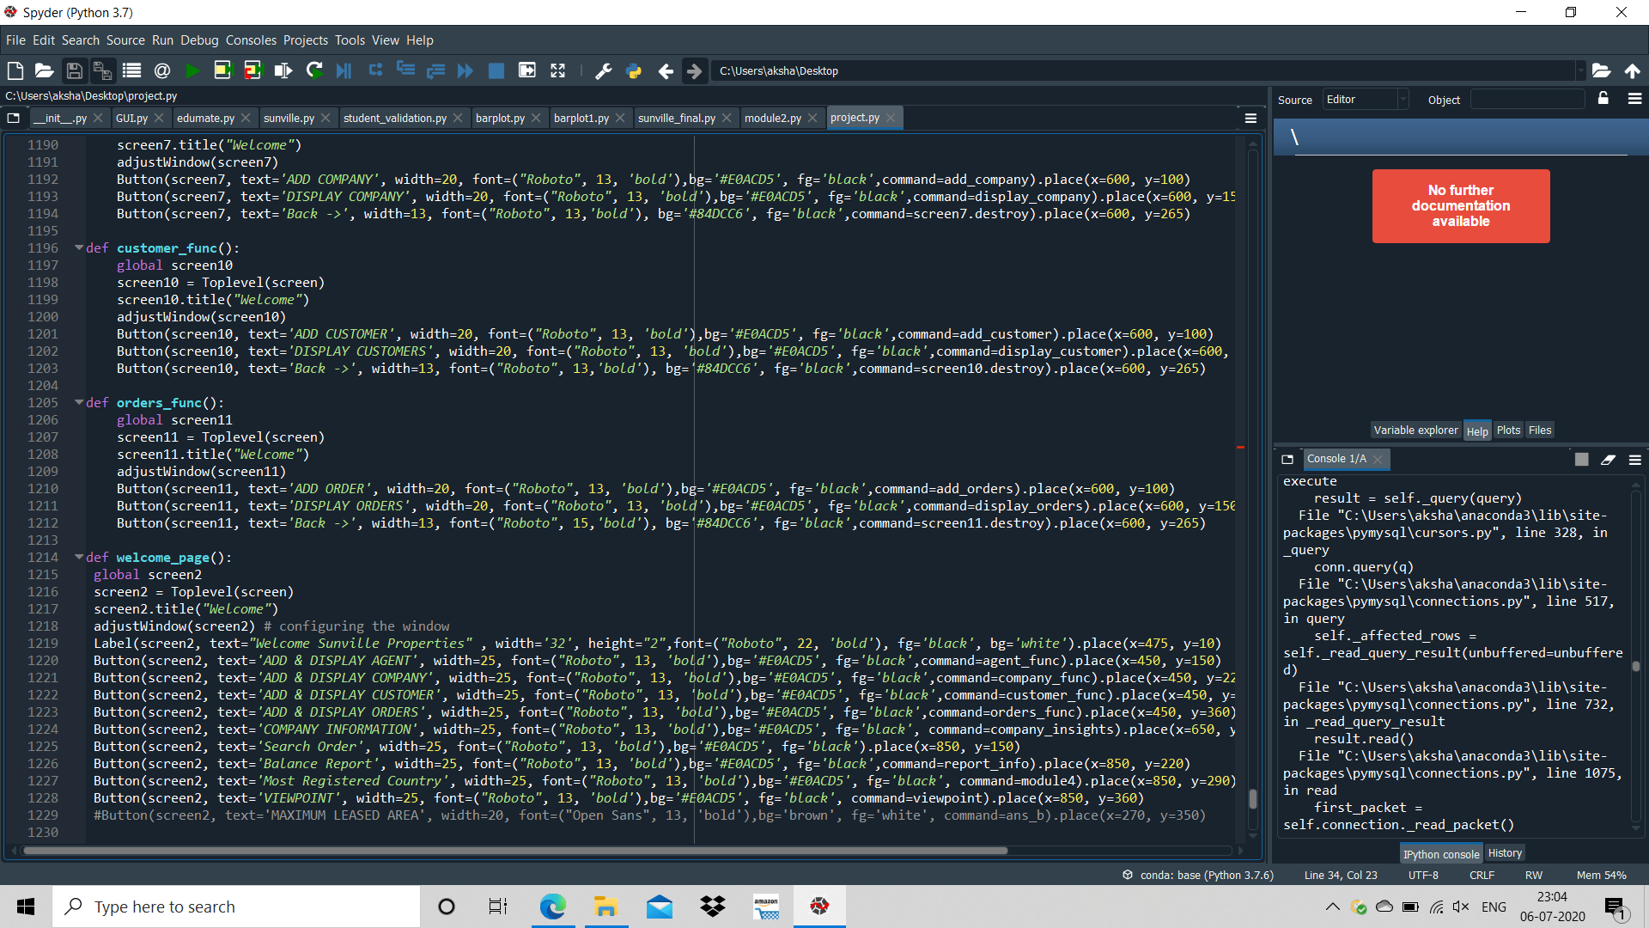

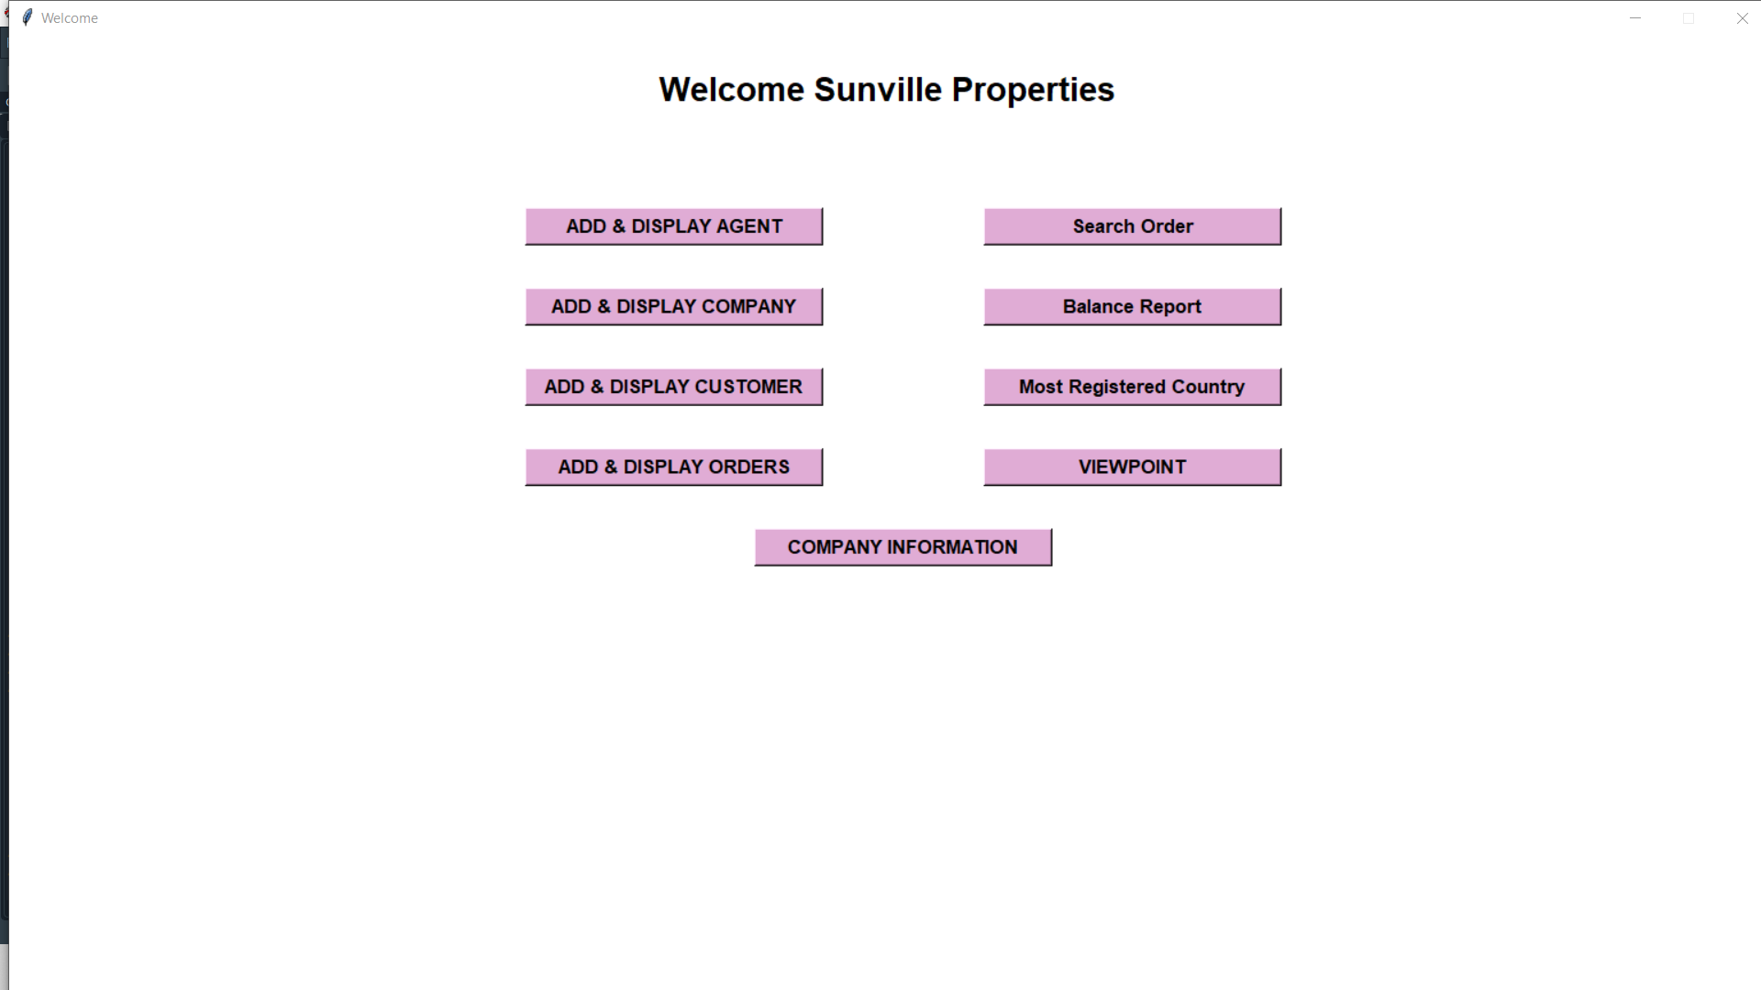

Adding Agent:

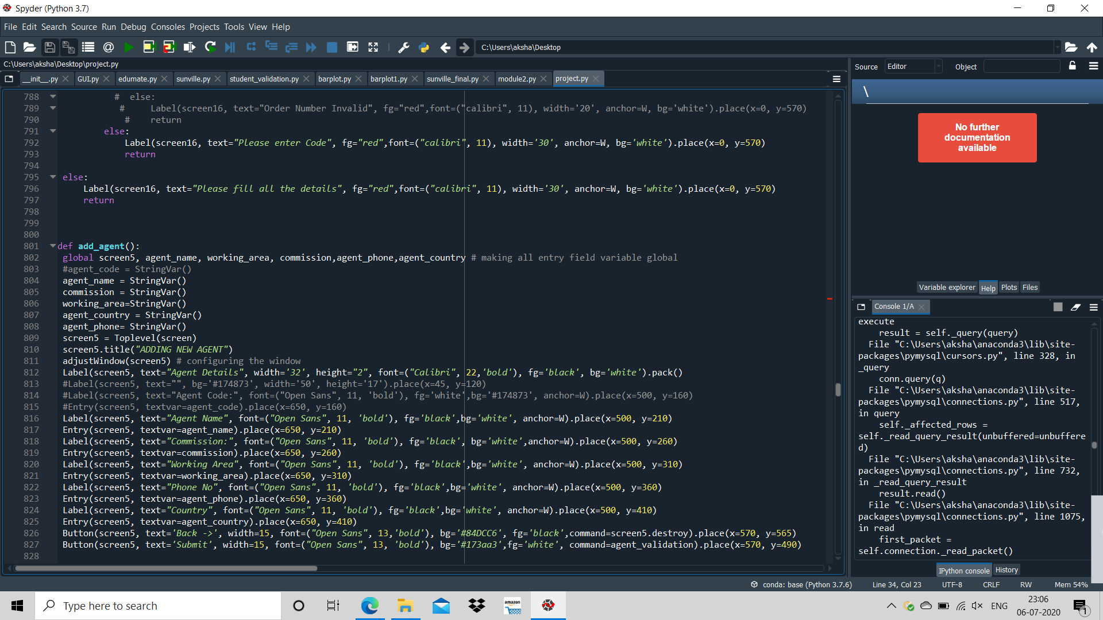

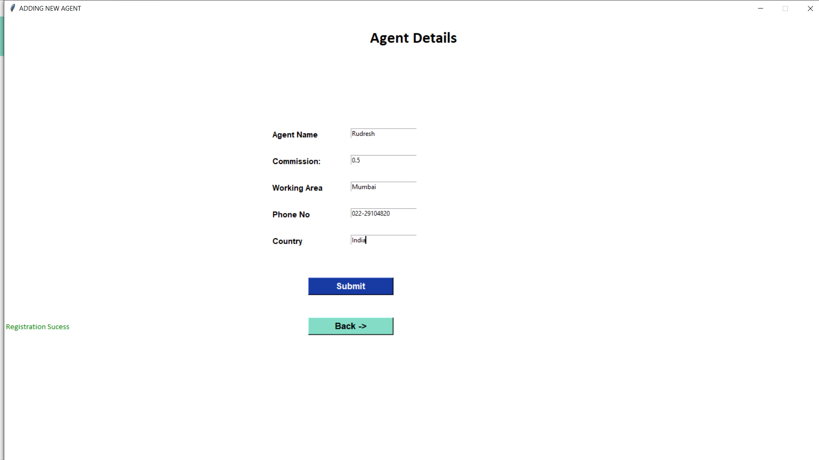

As the agent code is not taken as an input from the user, it is auto-generated. The code for this problem is given below:

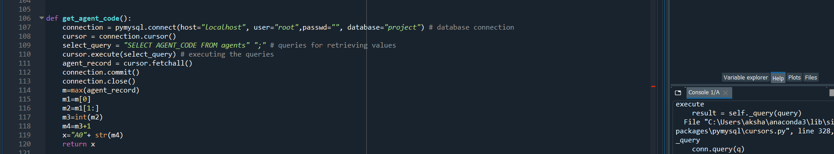

Displaying Agents:

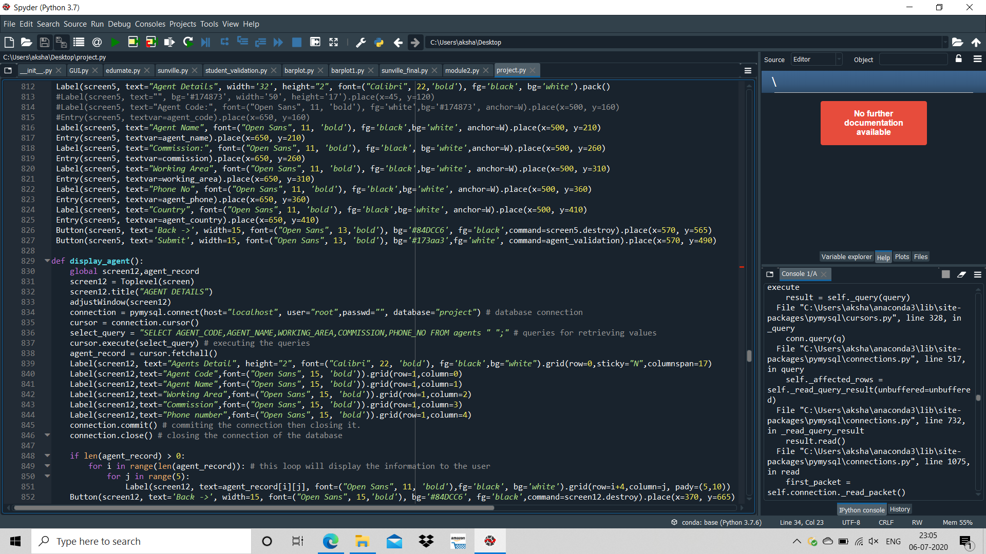

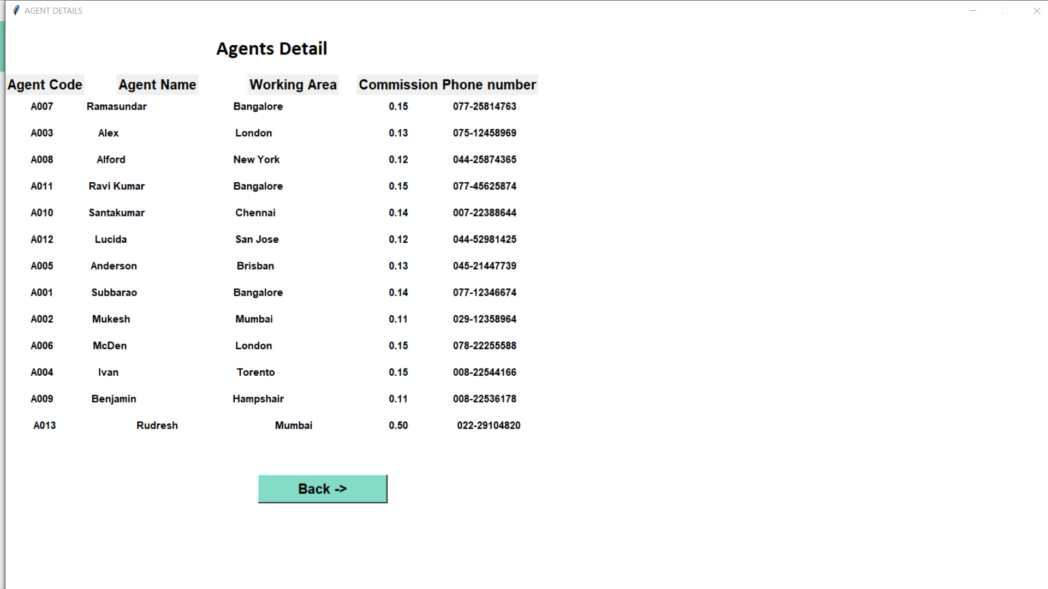

Adding Company:

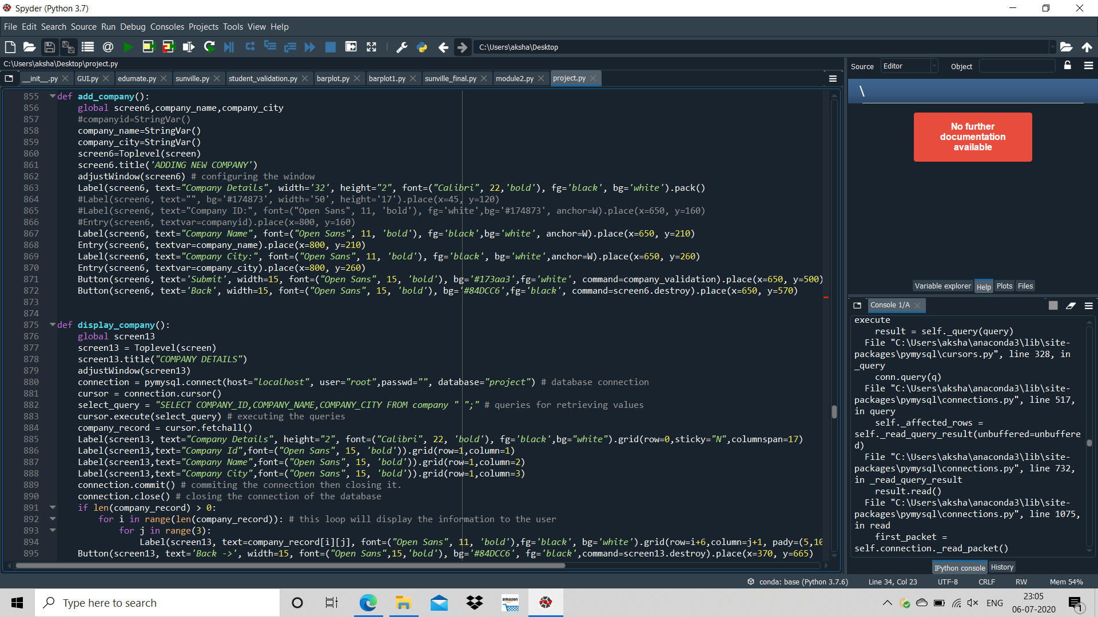

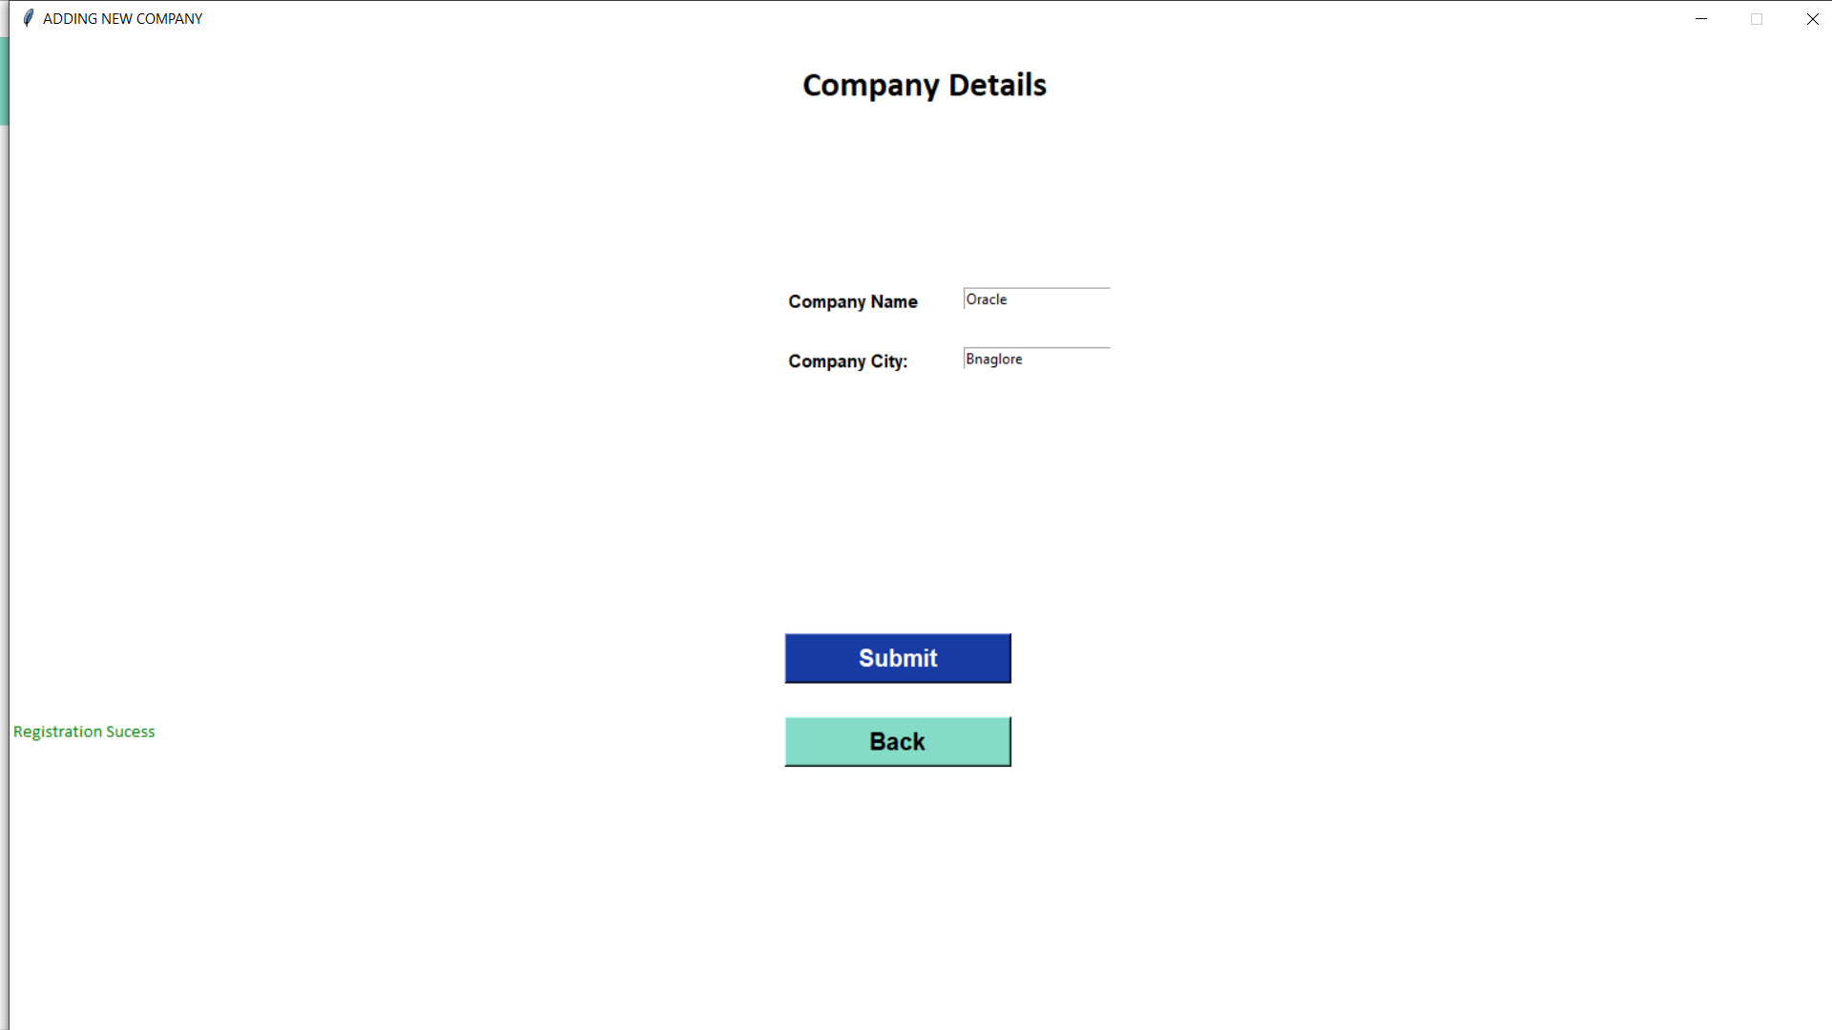

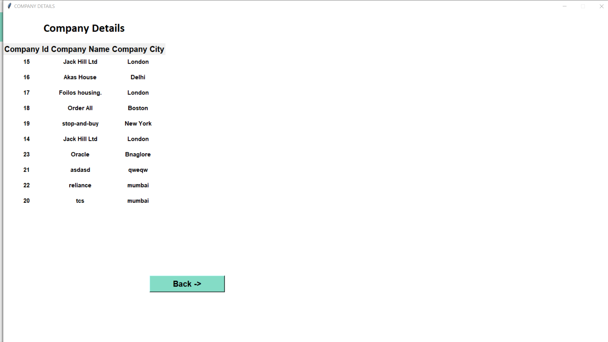

ADD ORDERS:

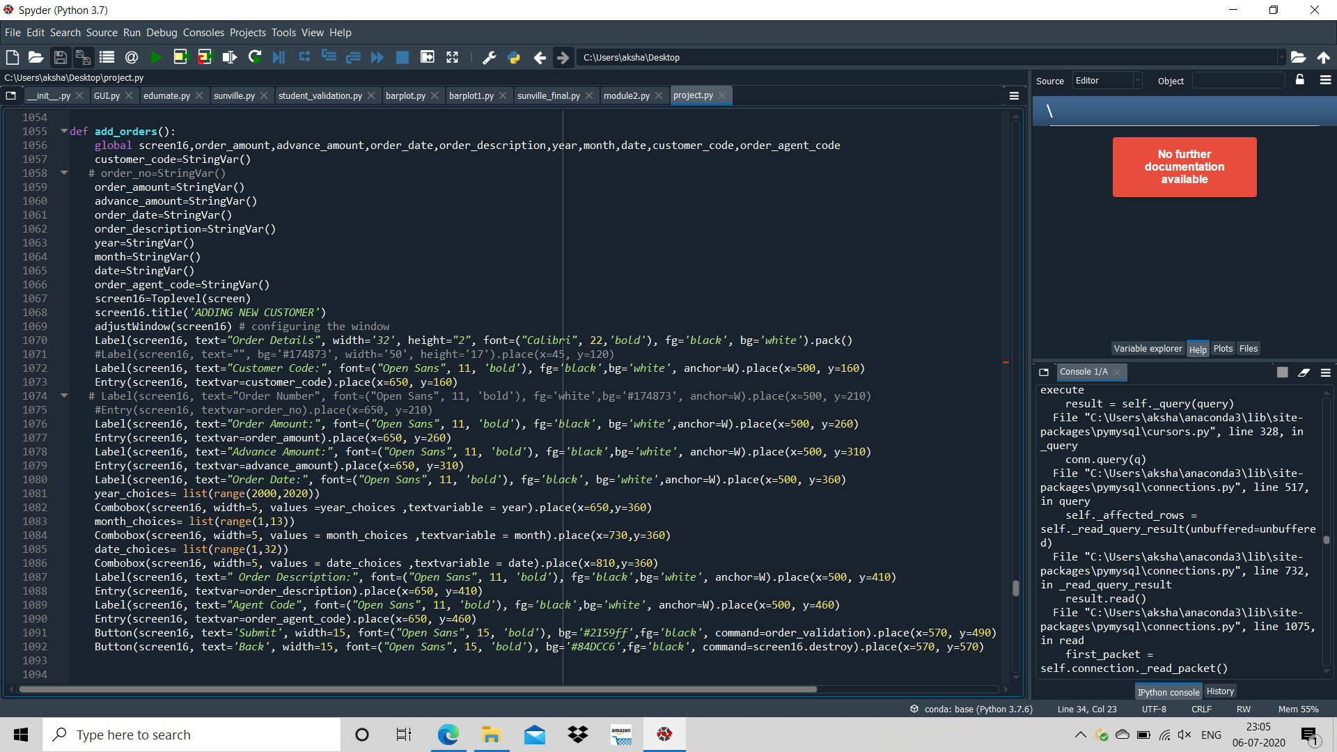

Display Orders:

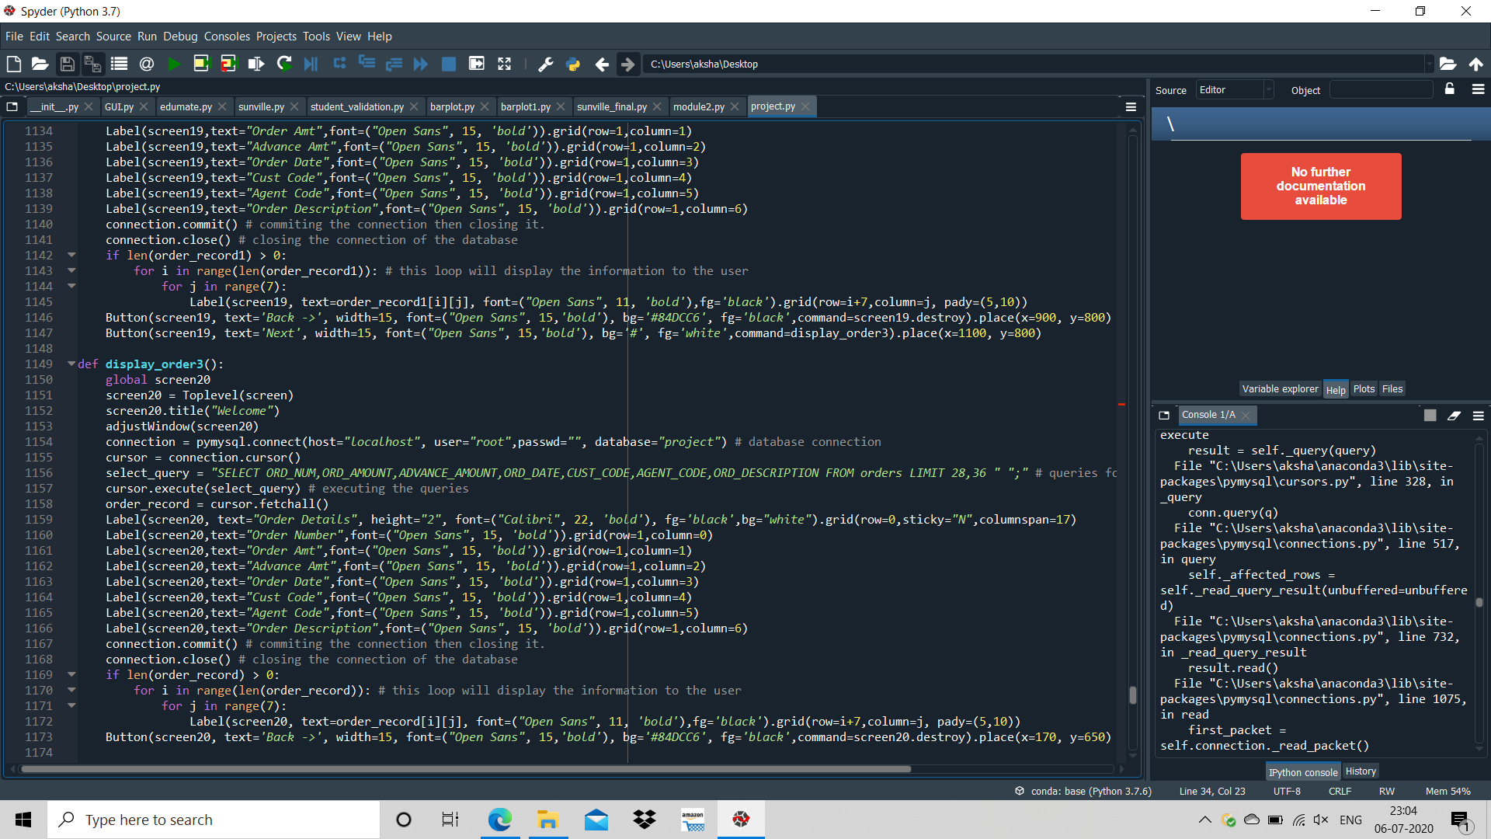

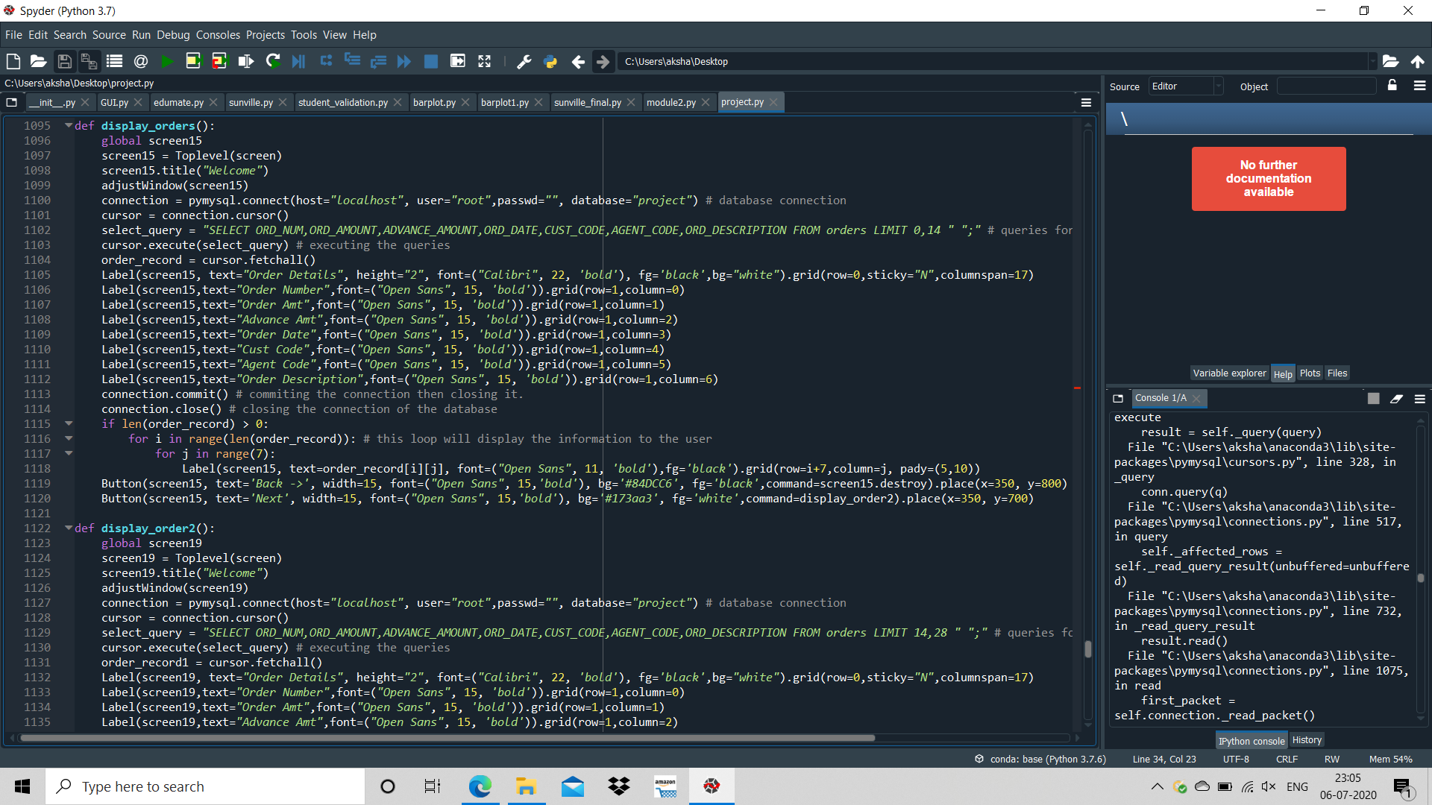

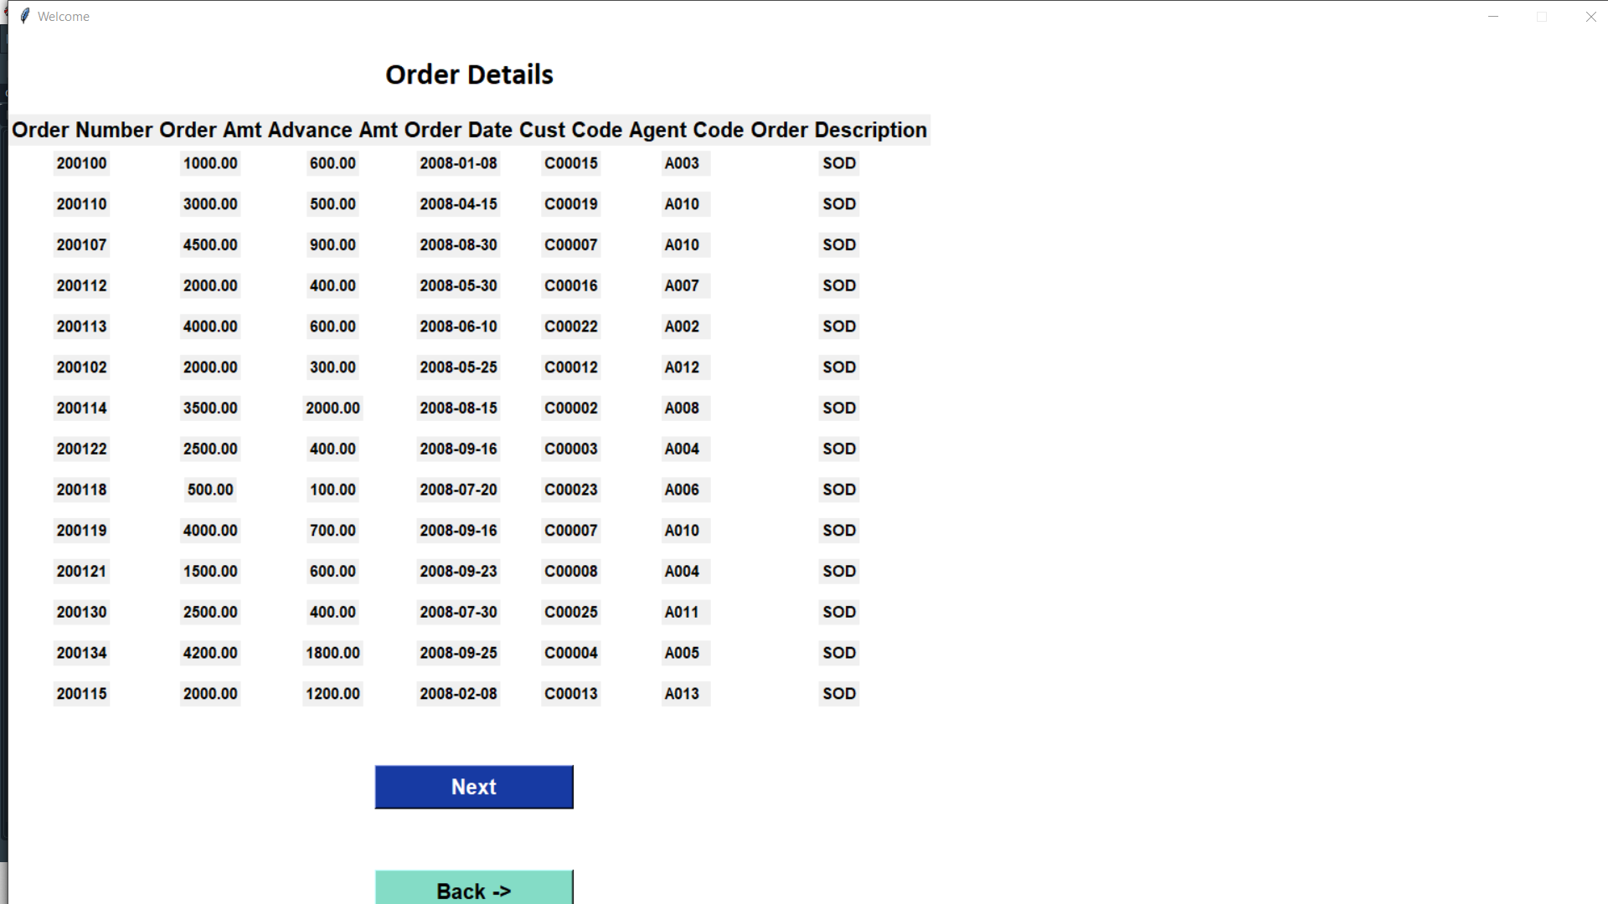

Adding Customers:

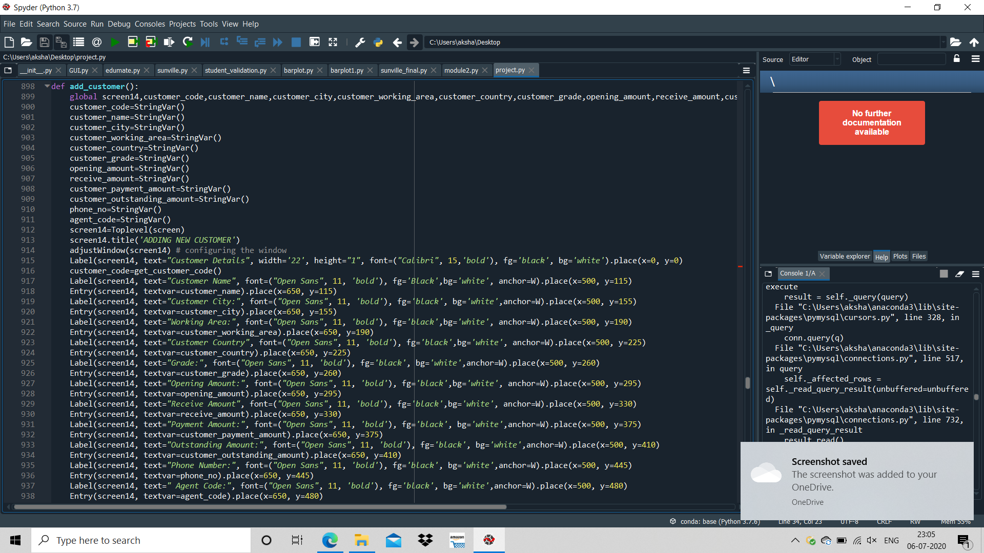

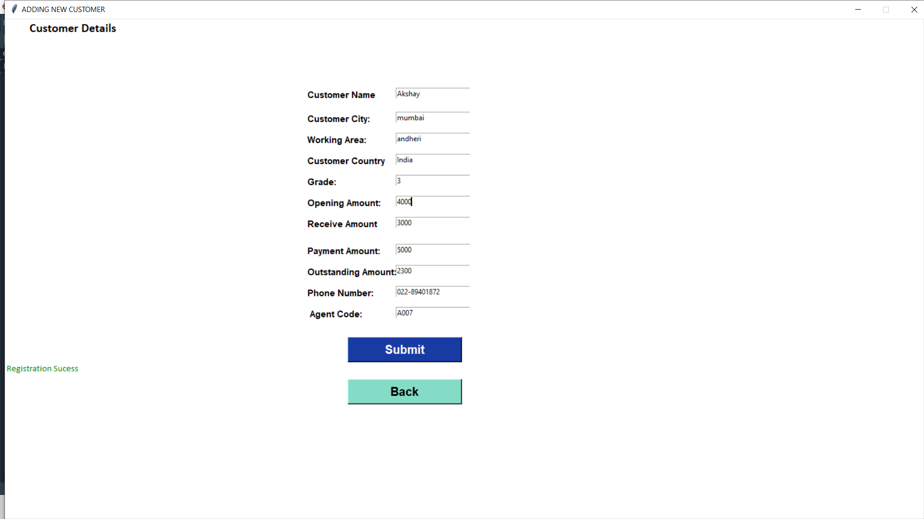

Display Customers:

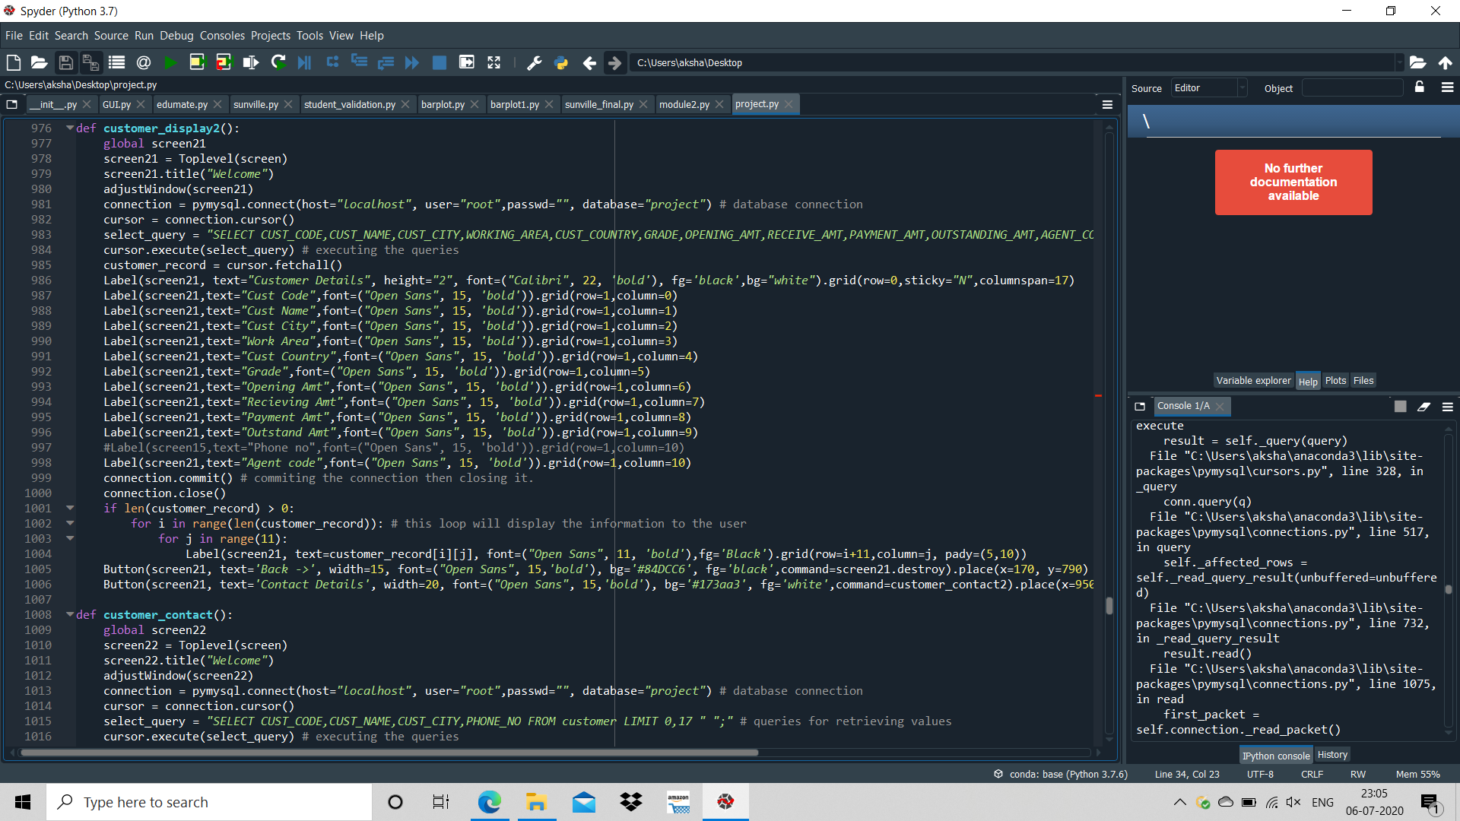

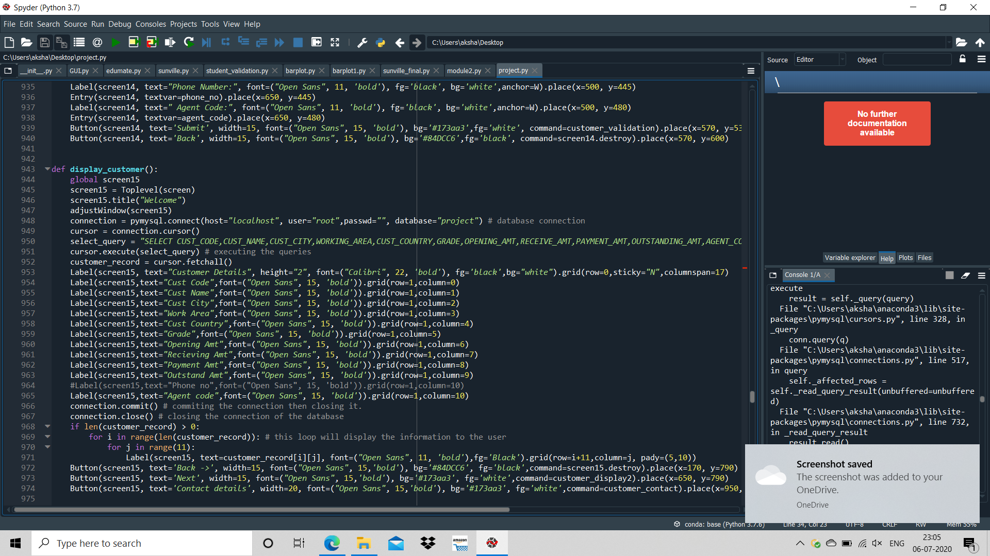

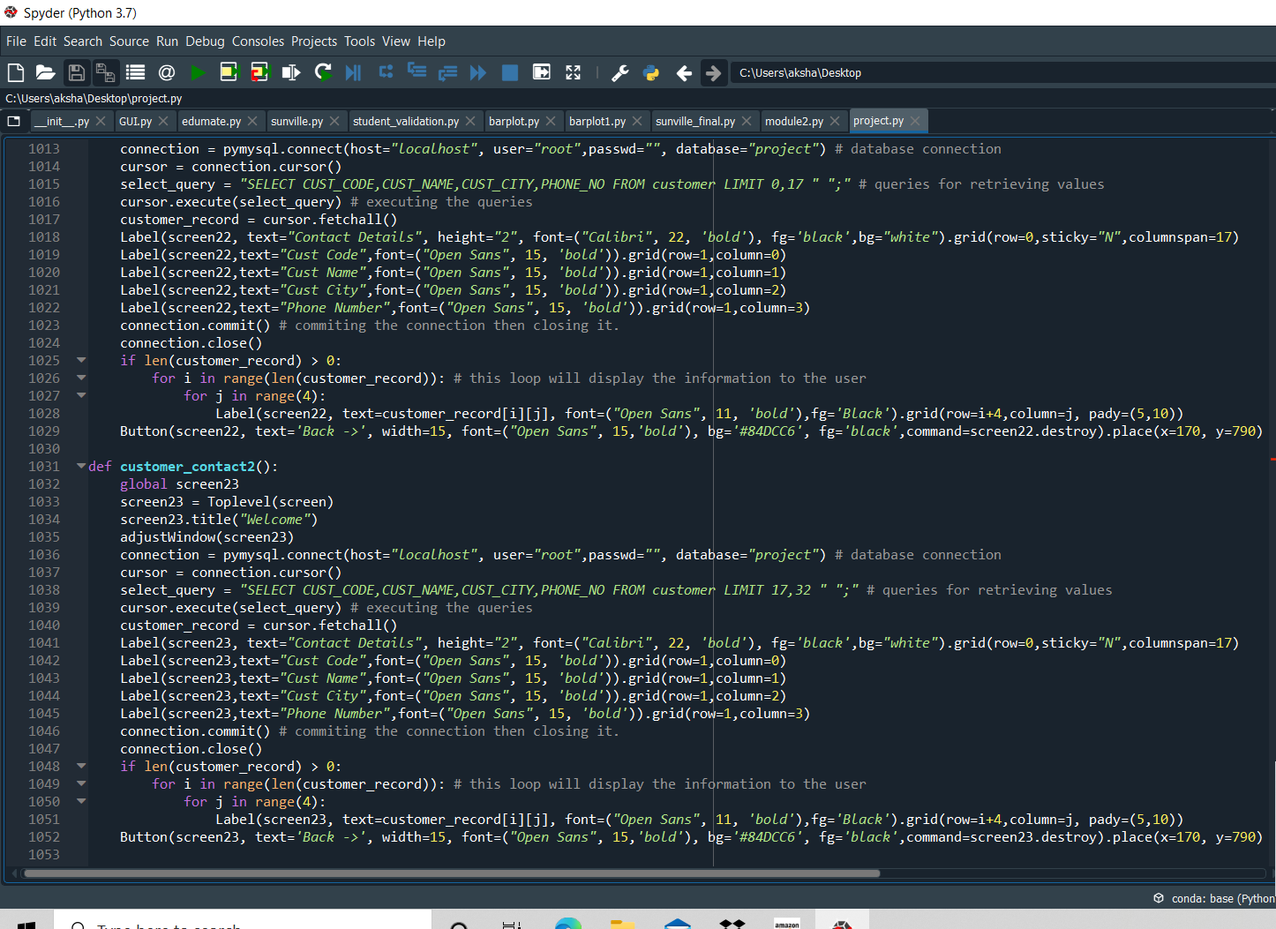

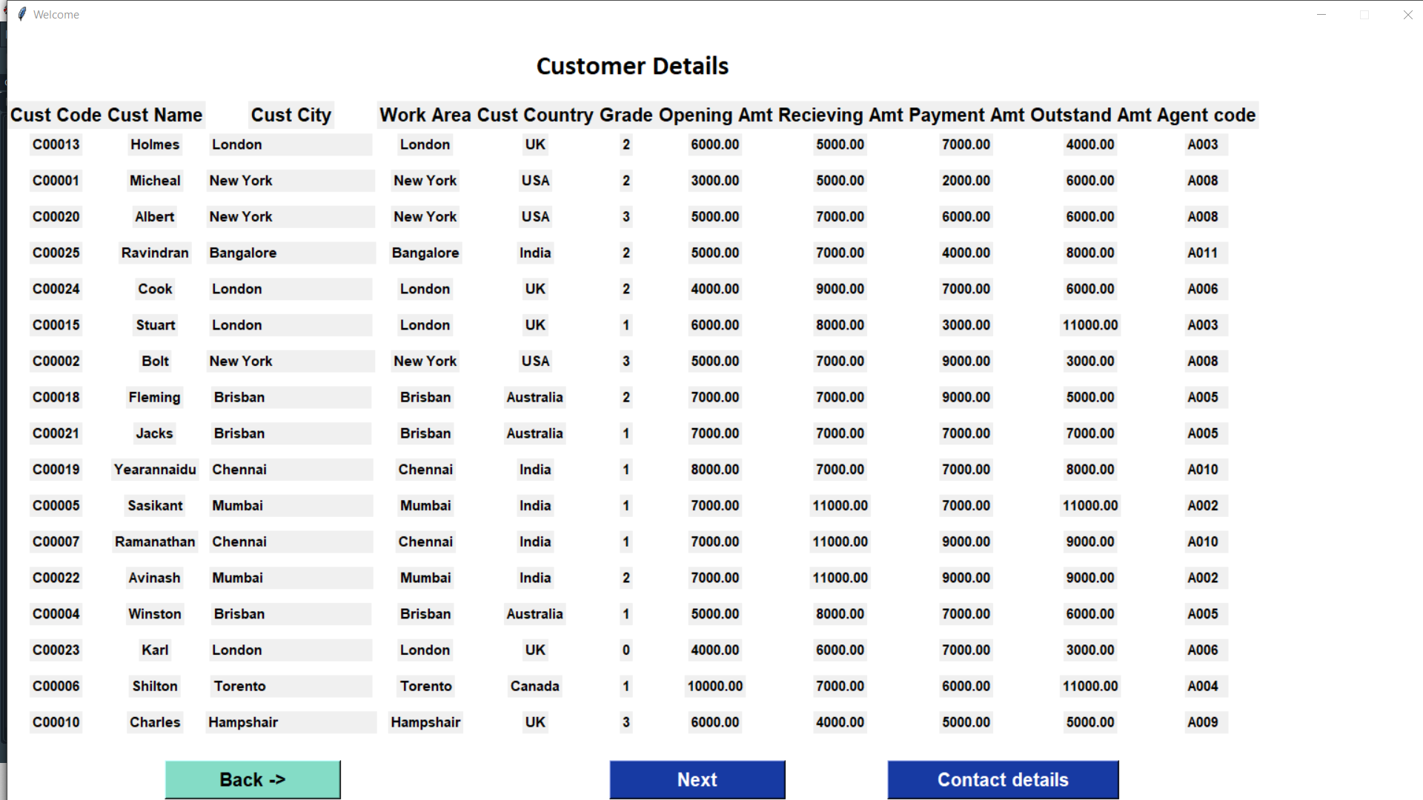

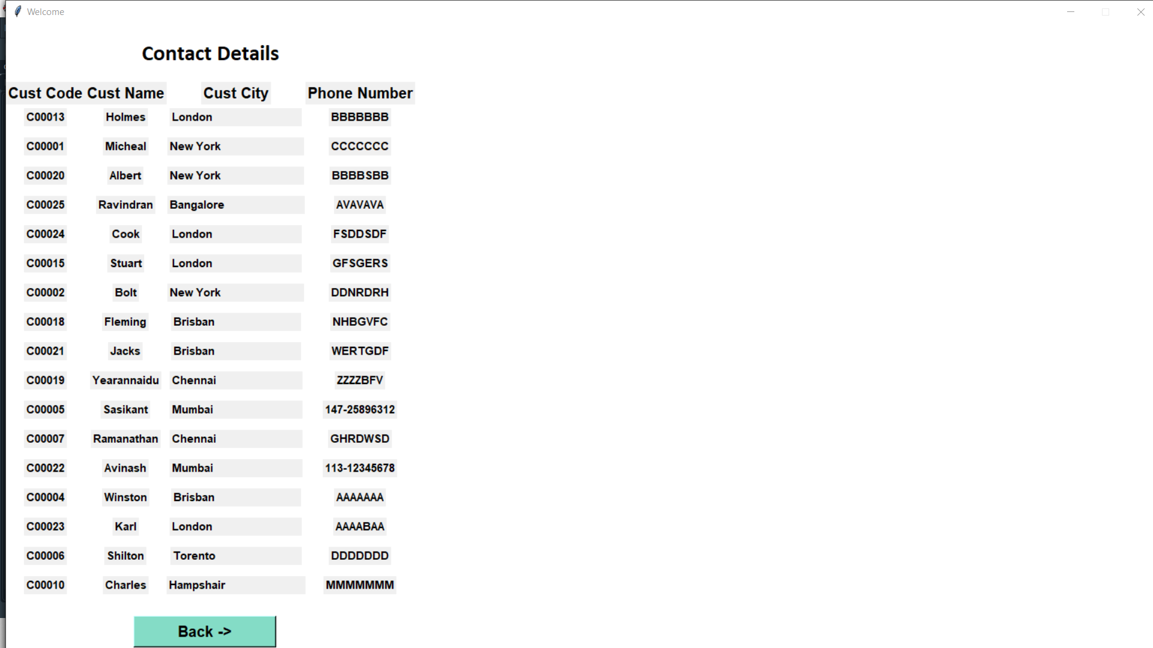

Code for auto-generating customer-code:

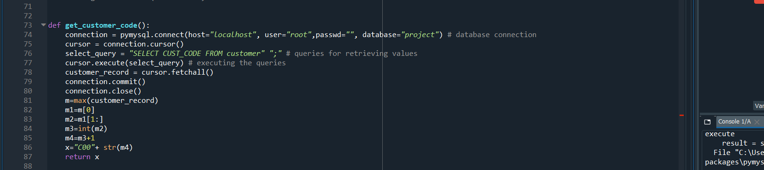

Balance Report:

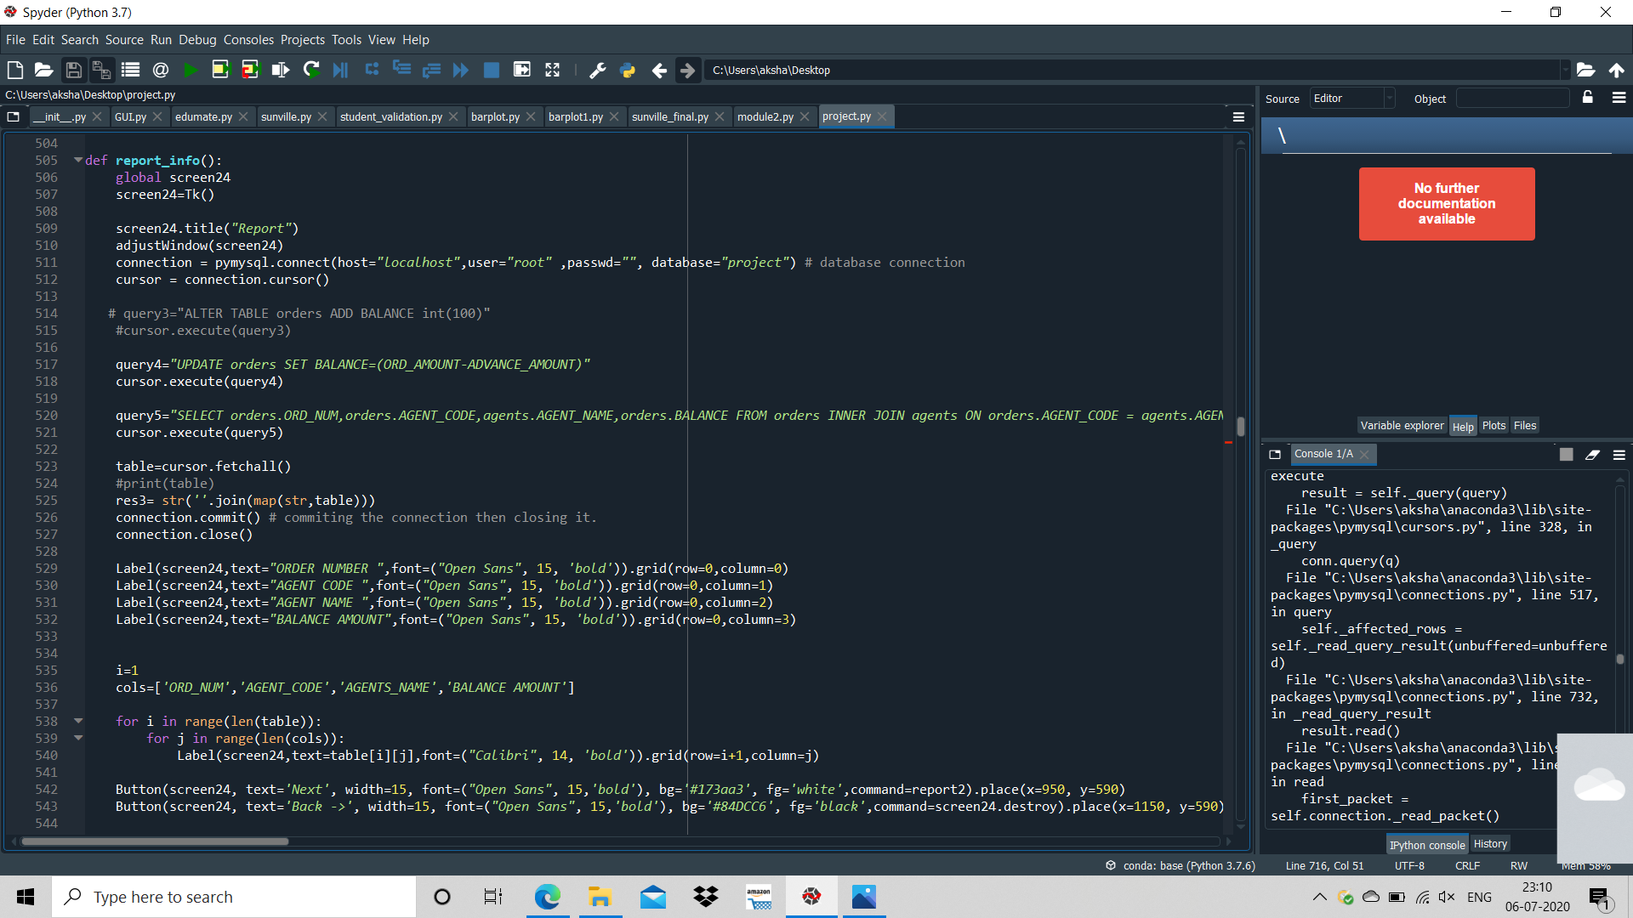

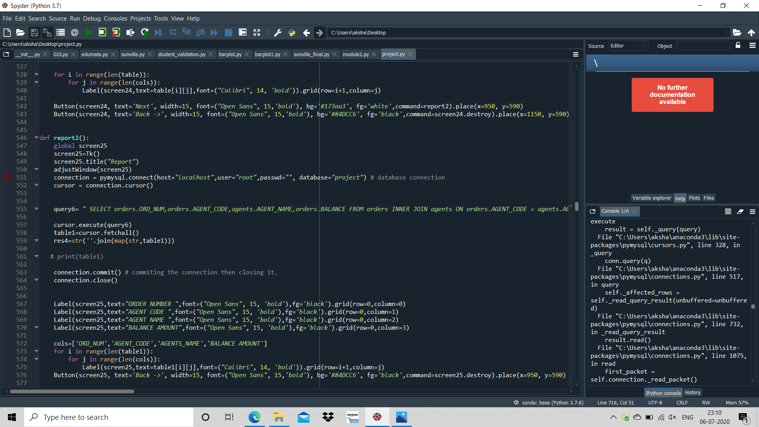

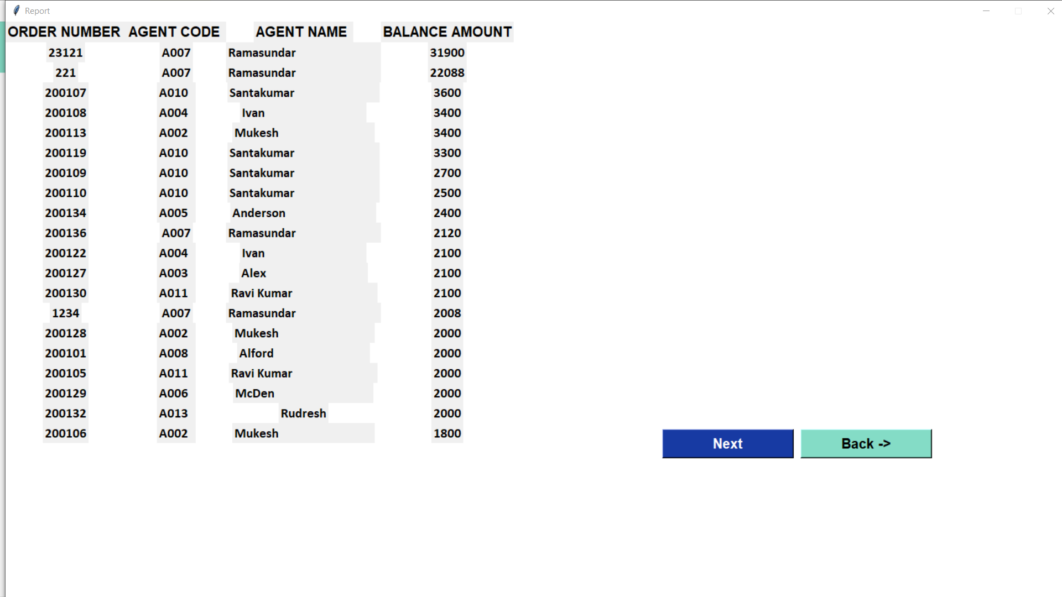

Company Insights:

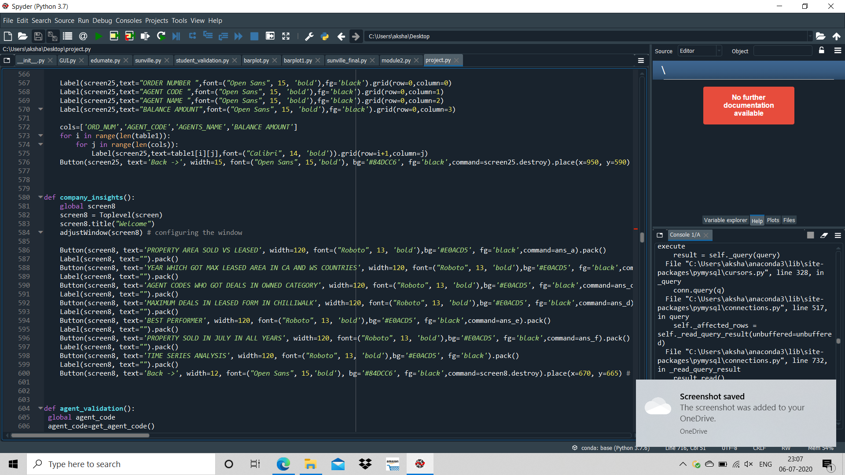

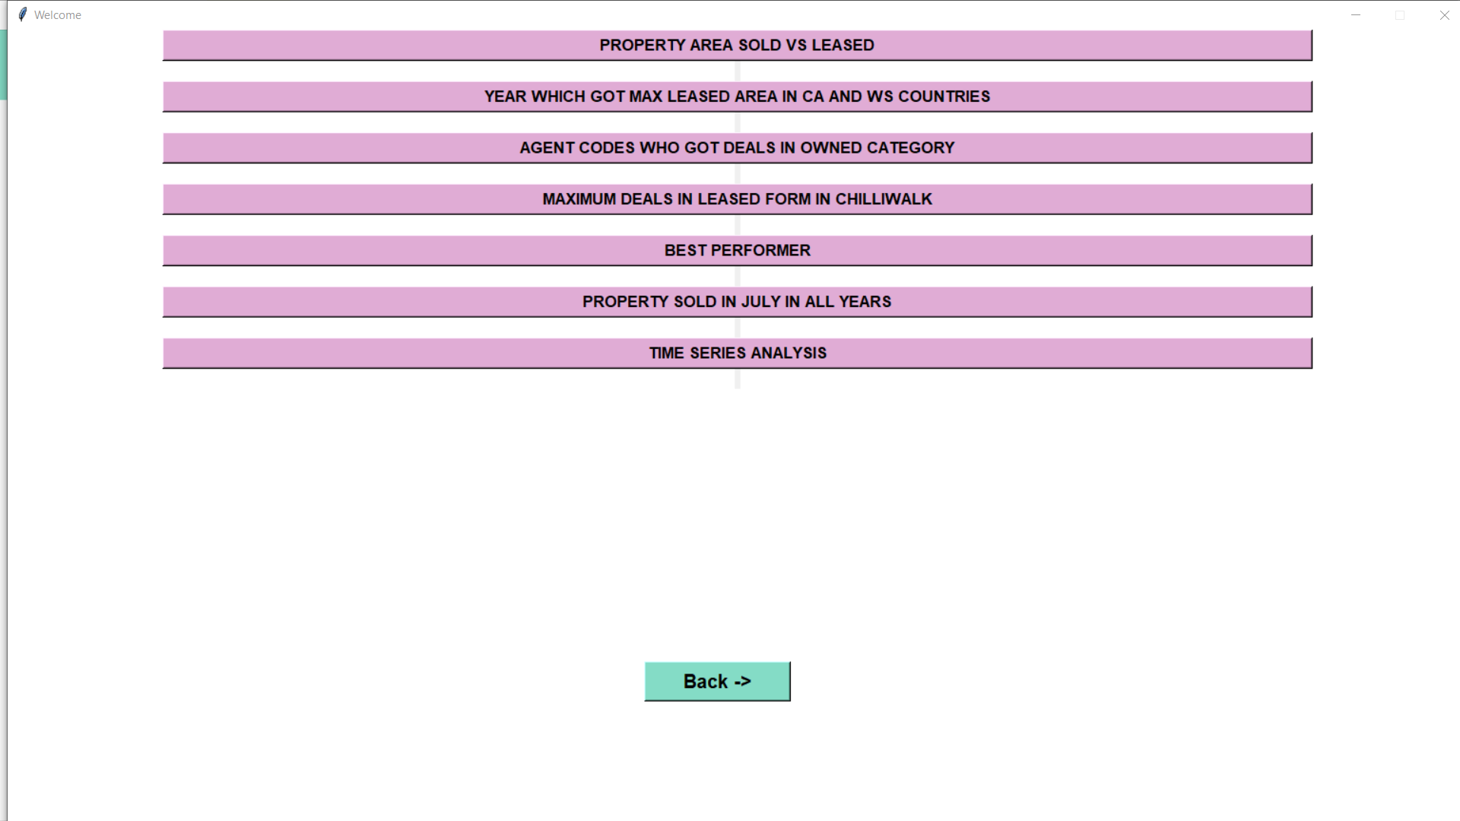

PROPERTY AREA SOLD VS LEASED:

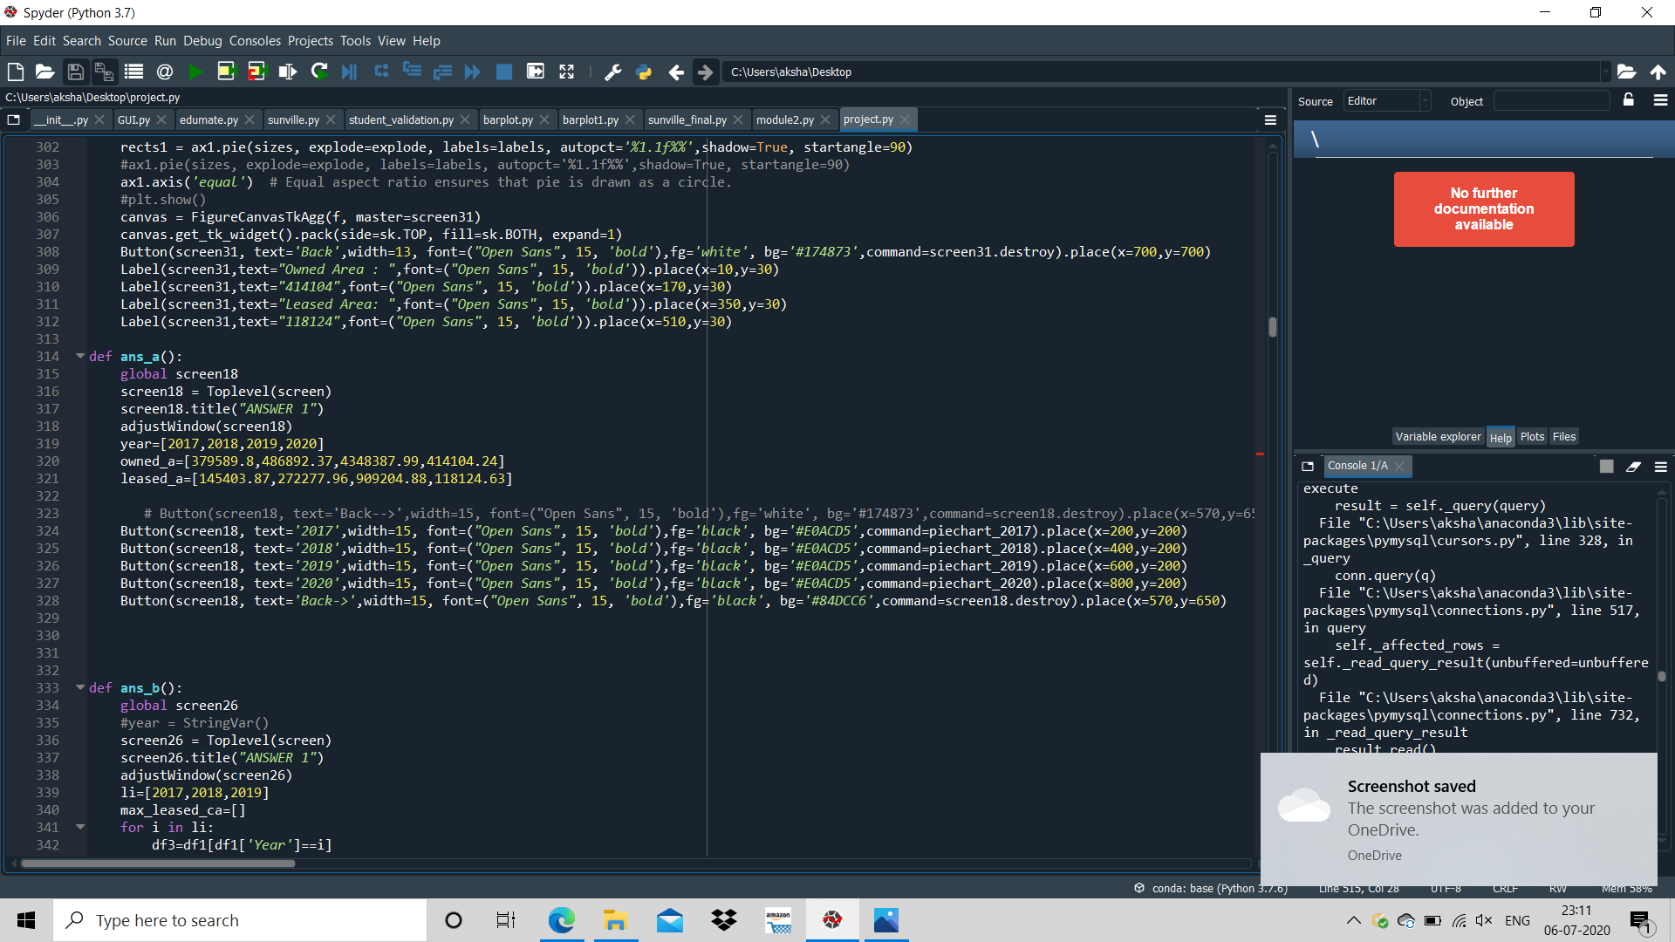

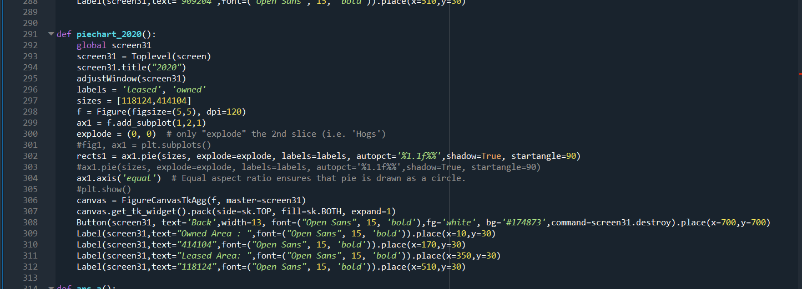

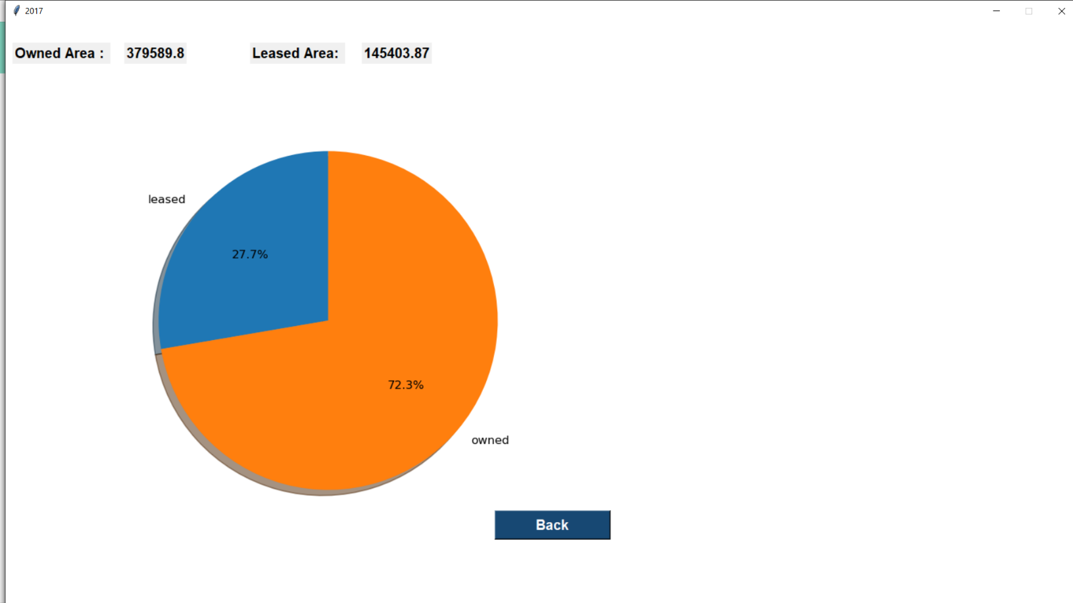

YEAR WHICH GOT MAXIMUM LEASED AREA IN CA AND WS COUNTRIES:

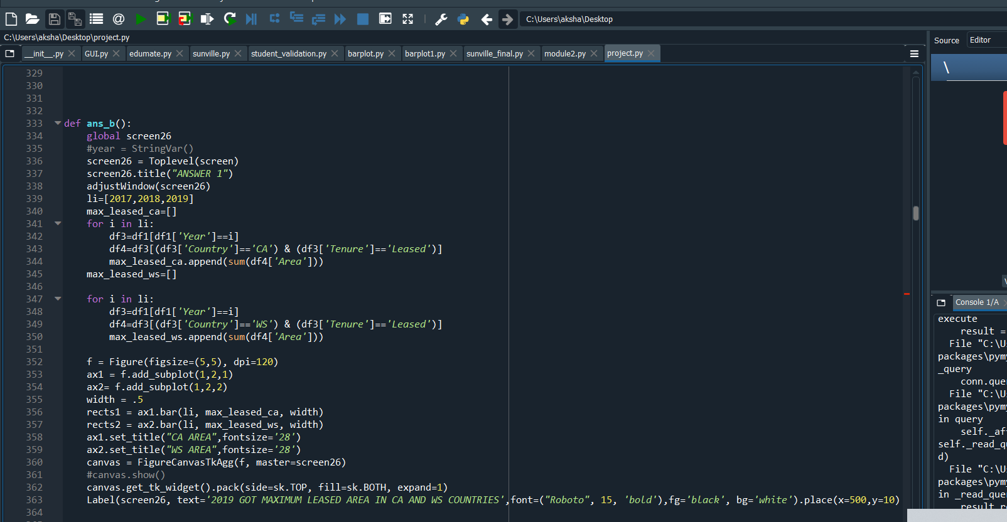

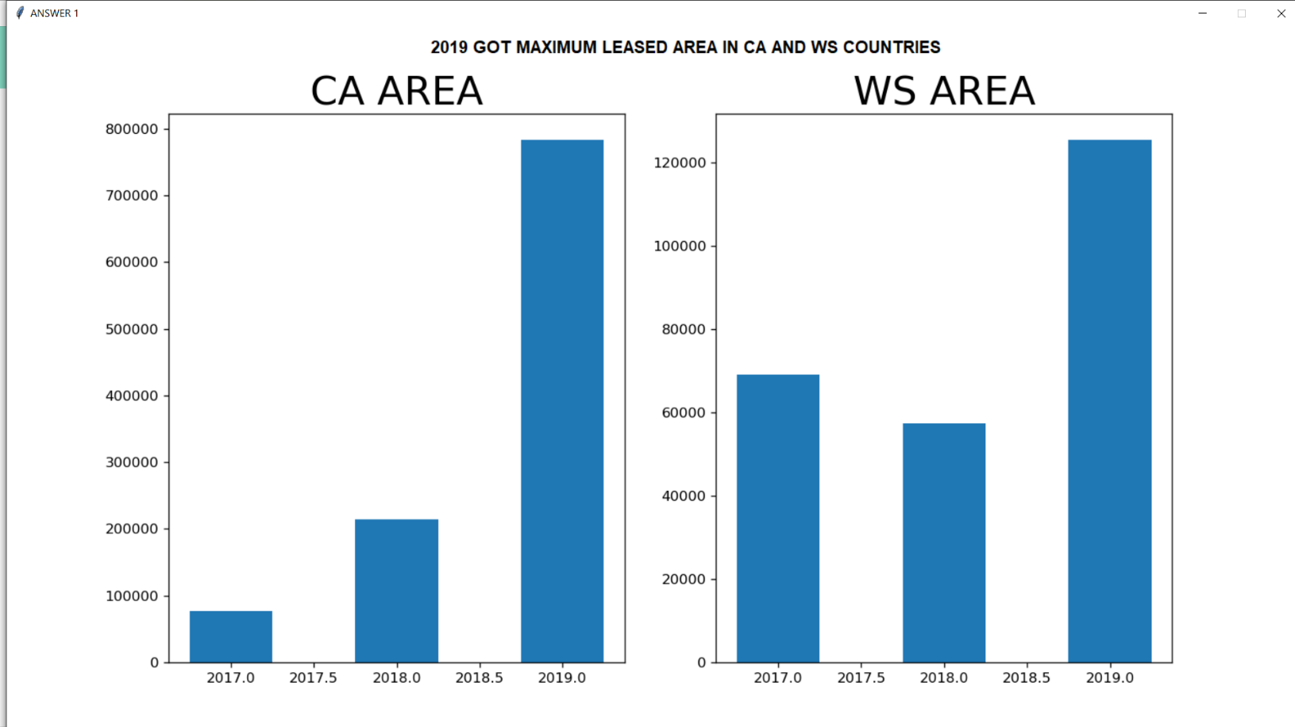

AGENT CODE WHO GOT DEALS IN OWNED CATEGORY:

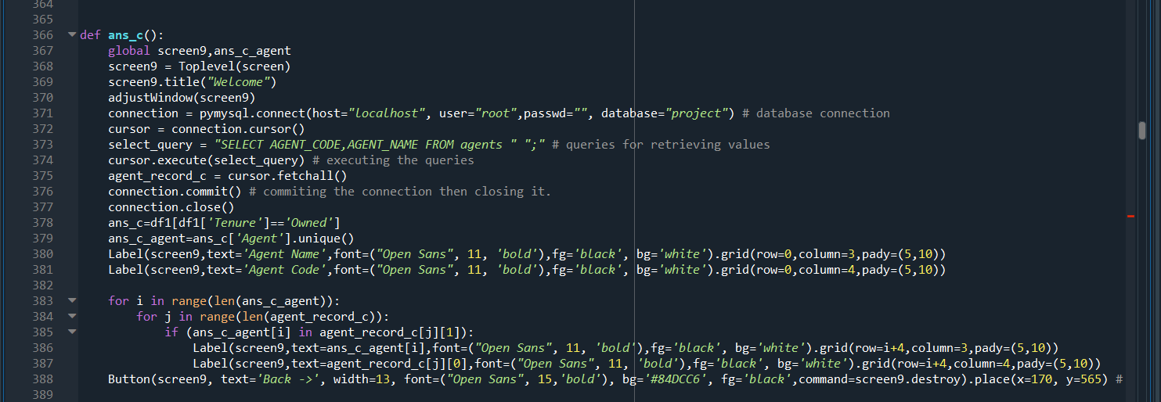

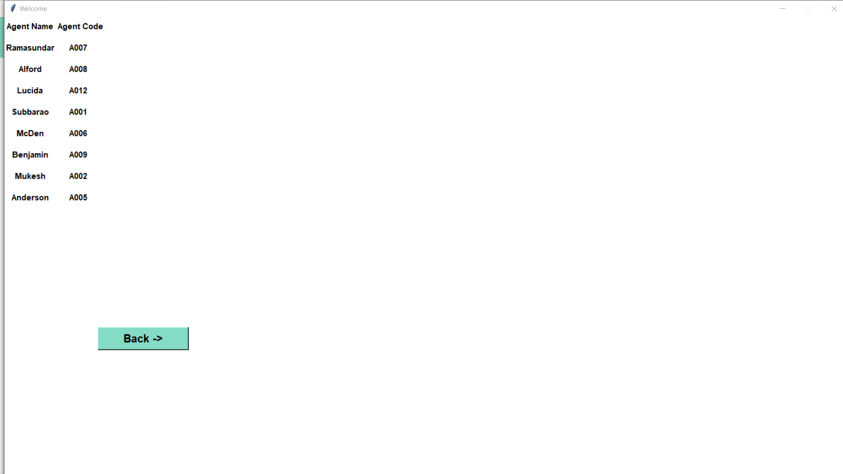

MAXIMUM DEALS IN LEASED FORM IN CHILLIWALCK

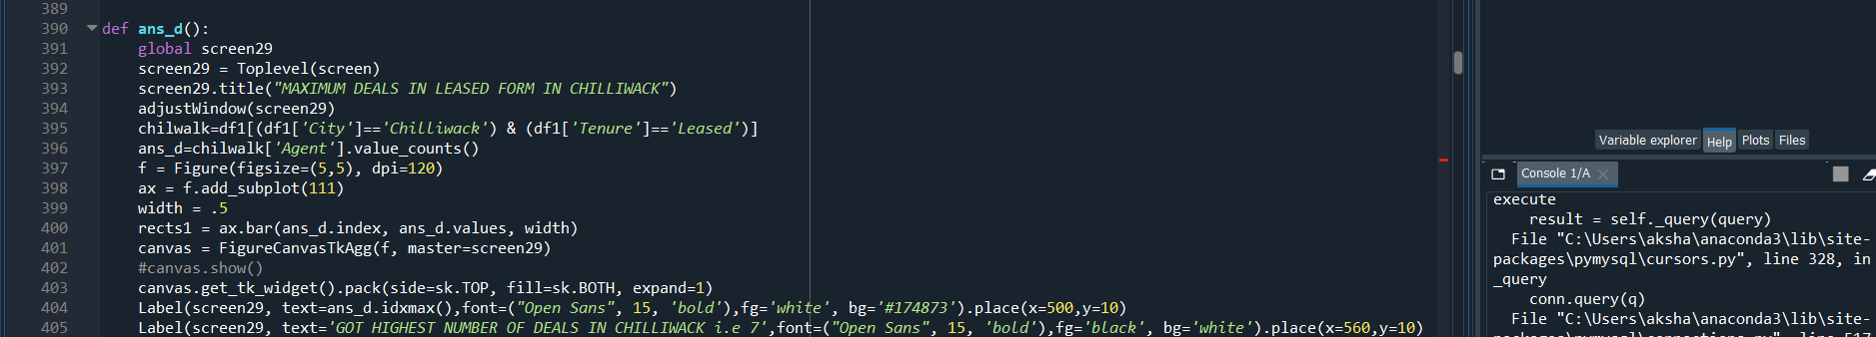

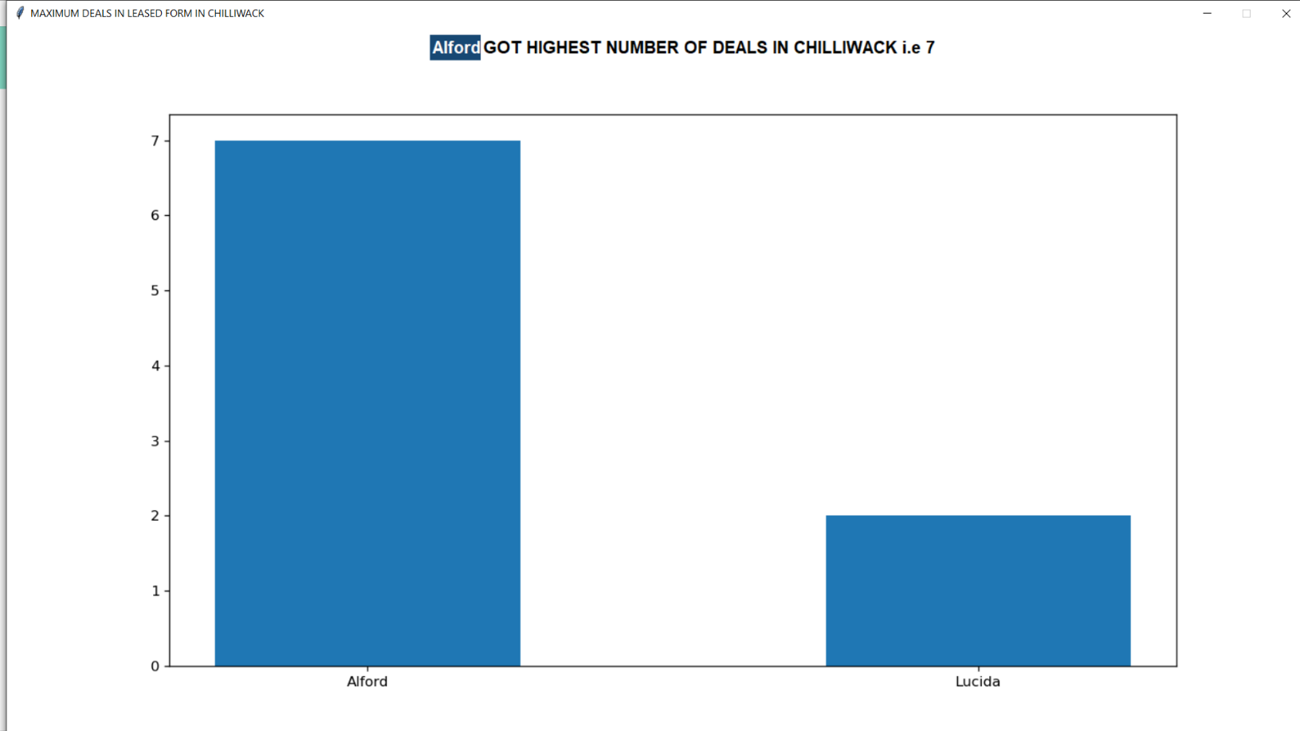

BEST PERFORMER:

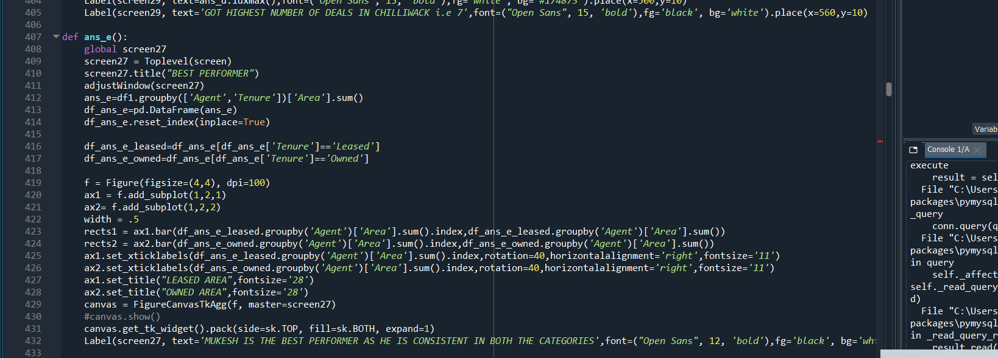

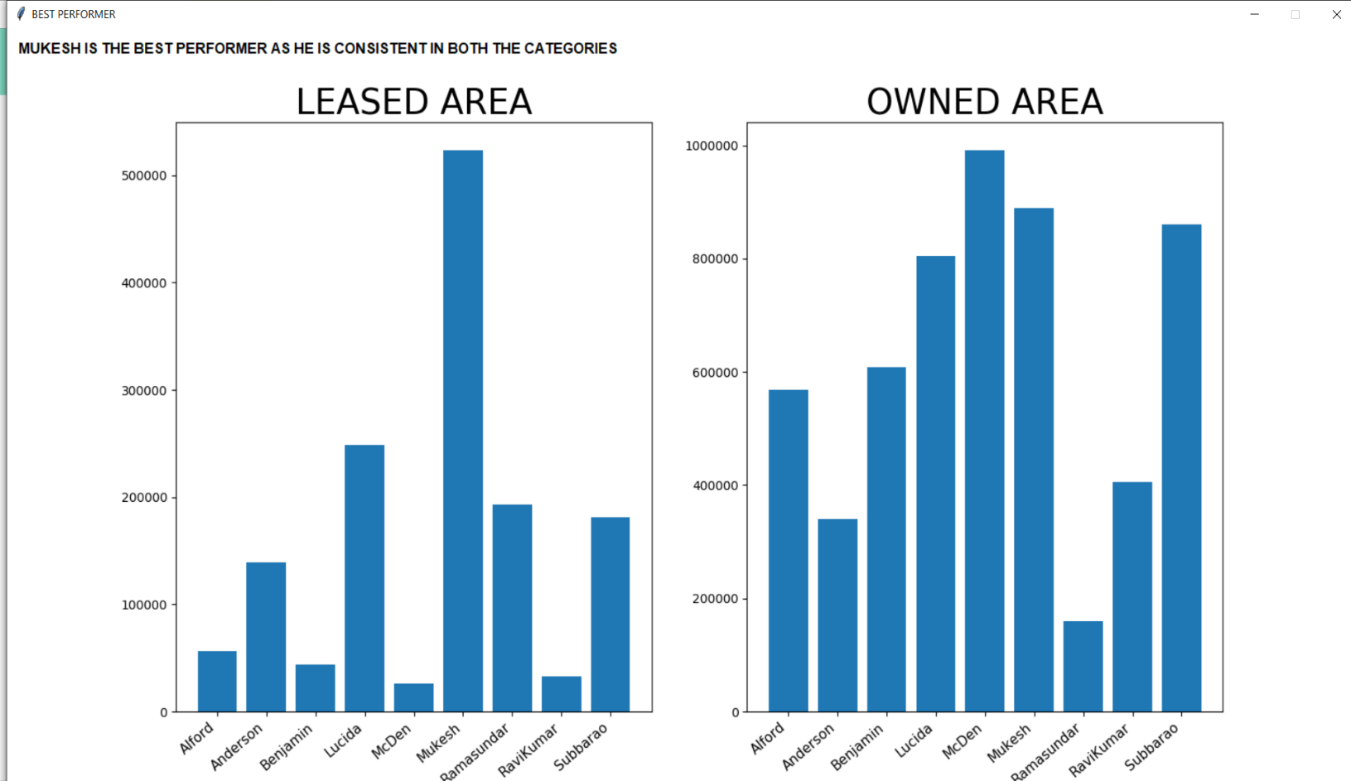

PROPERTY SOLD IN THE MONTH OF JULY IN ALL YEARS:

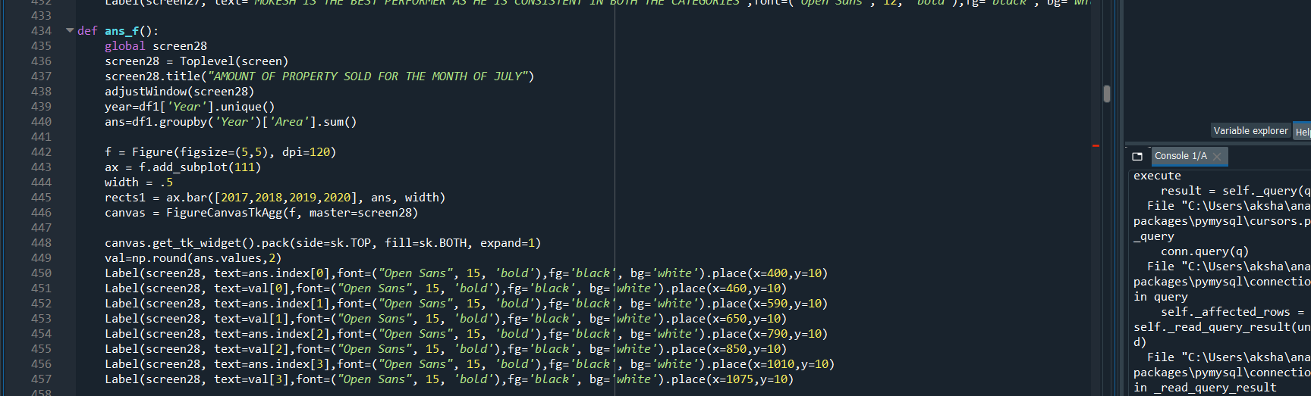

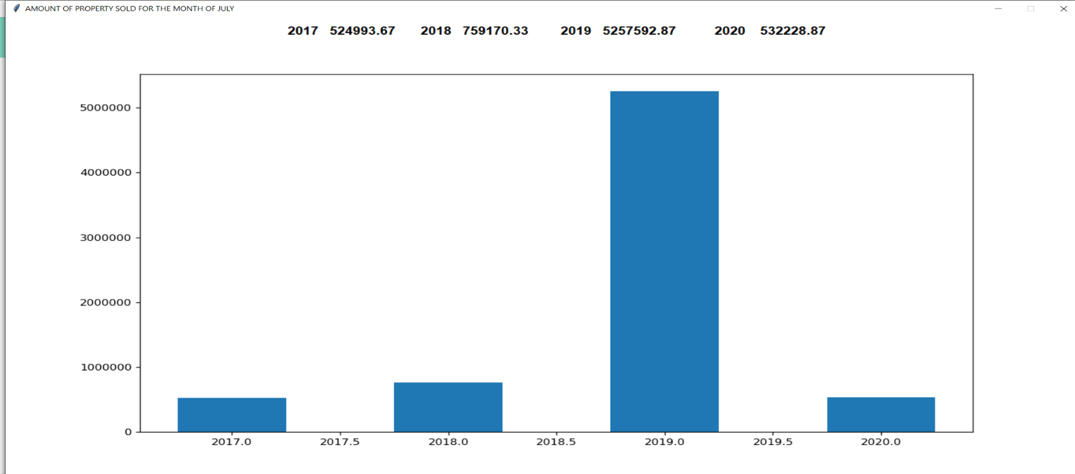

MOST REGISTERED COUNTRY:

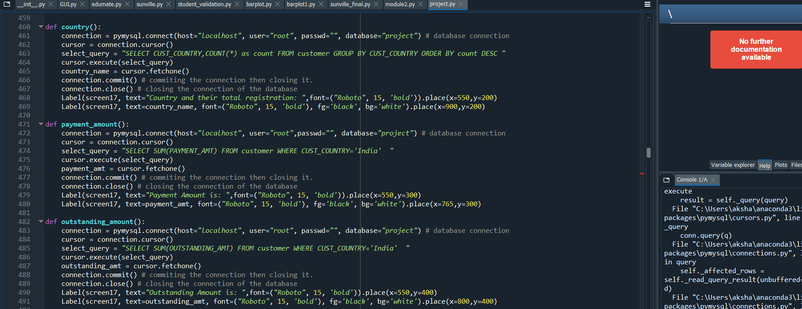

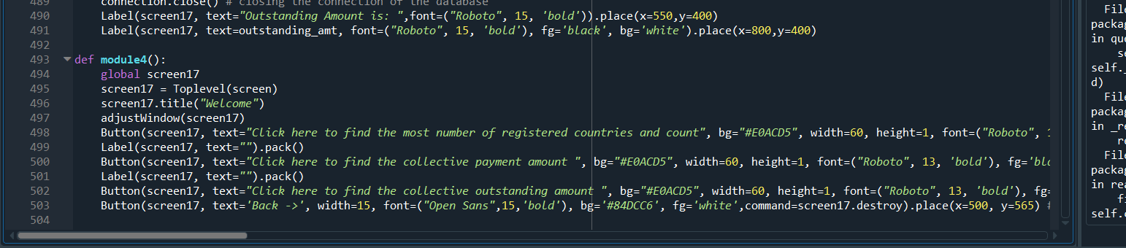

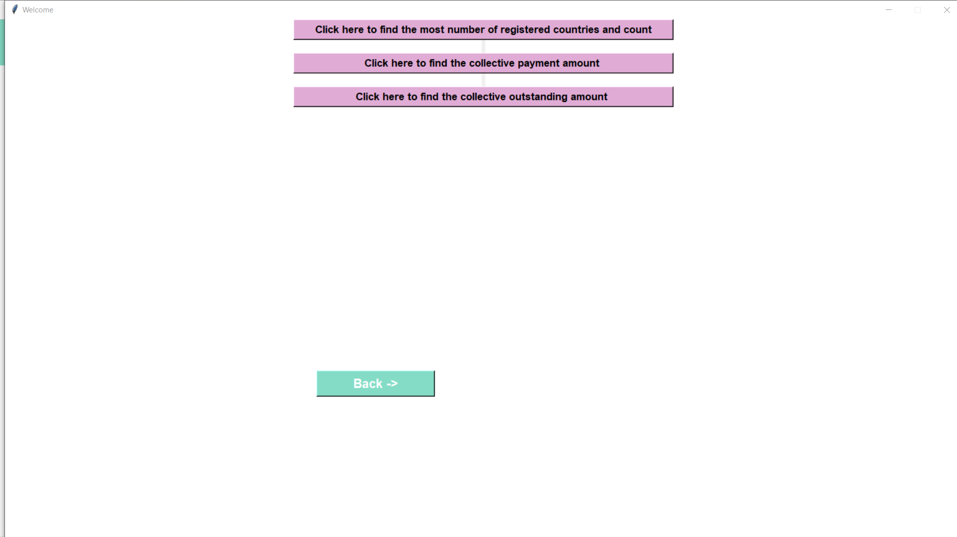

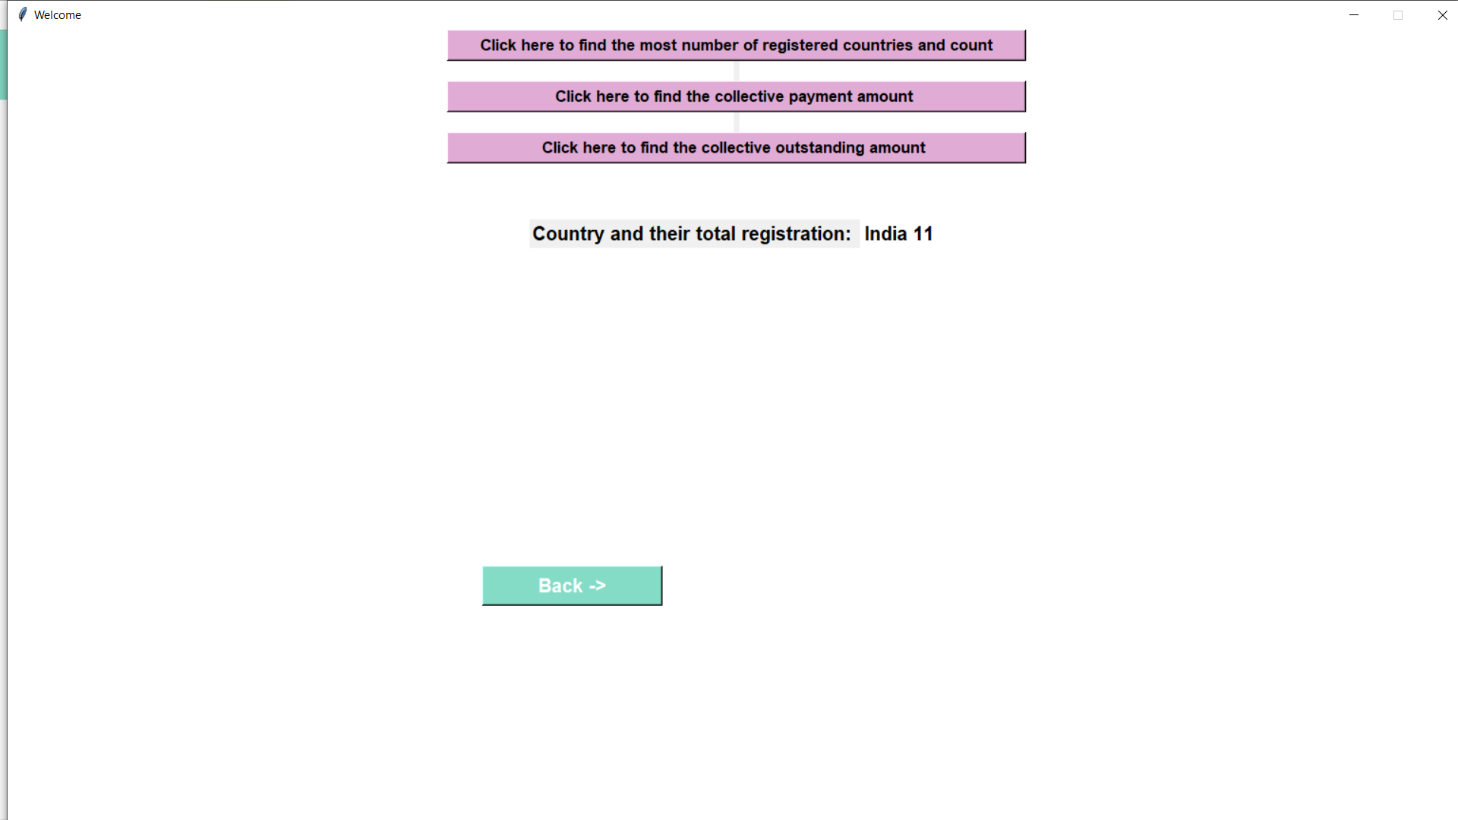

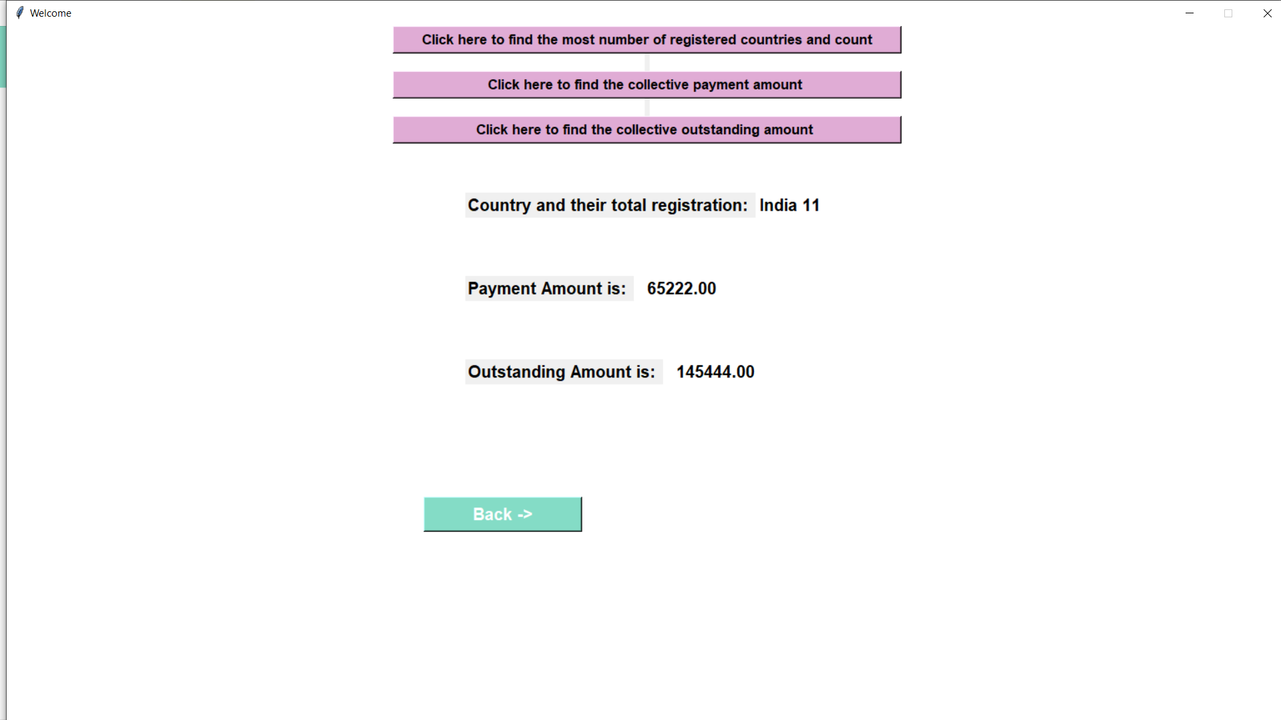

TIME SERIES ANALYSIS:

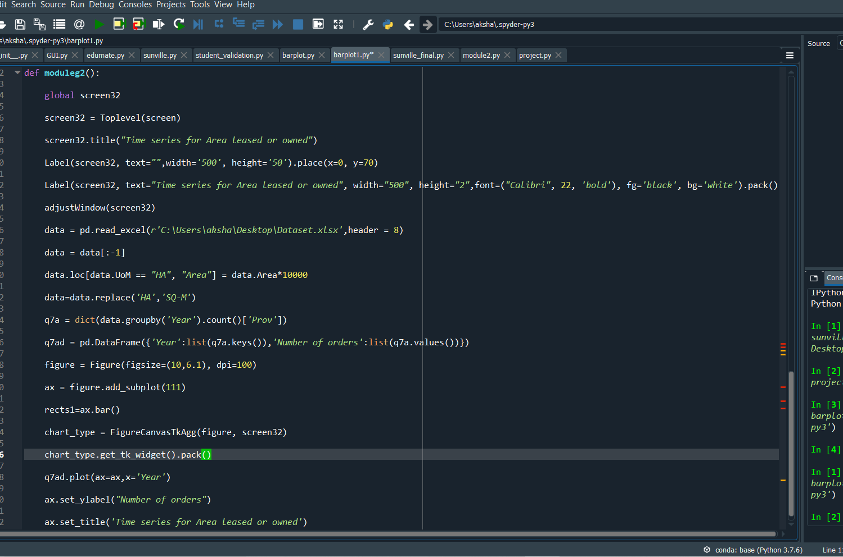

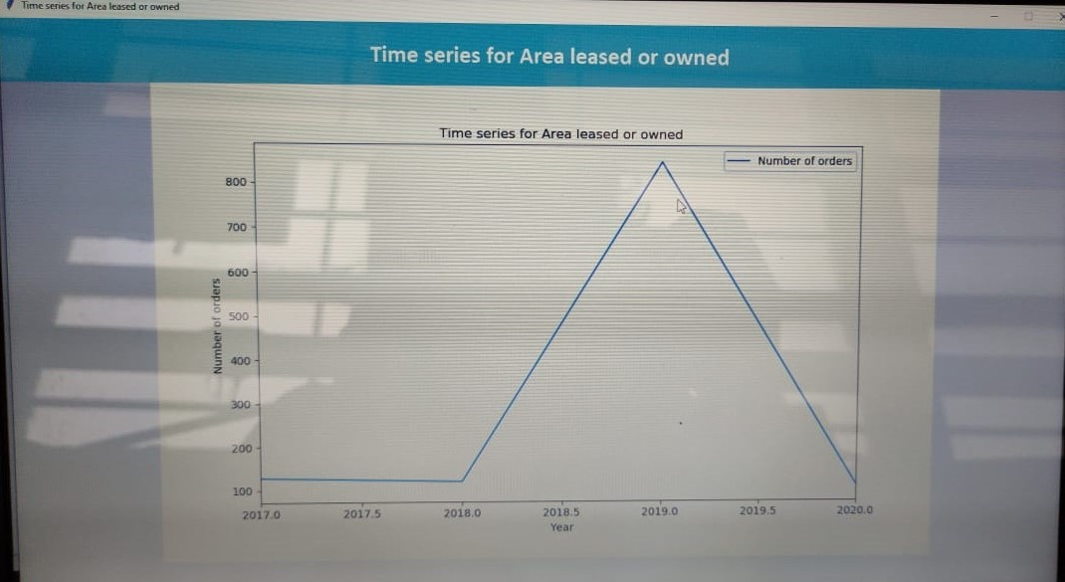

VIEWPOINT:

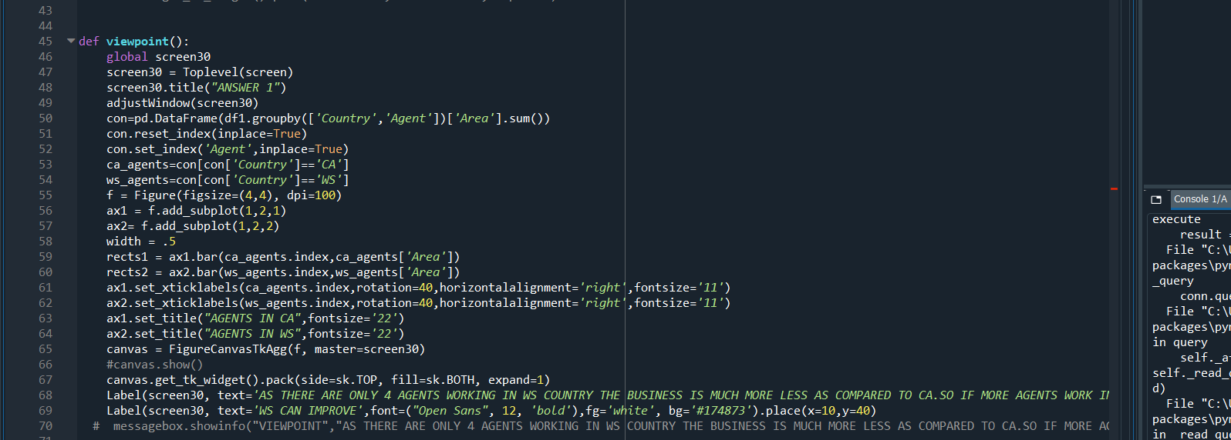

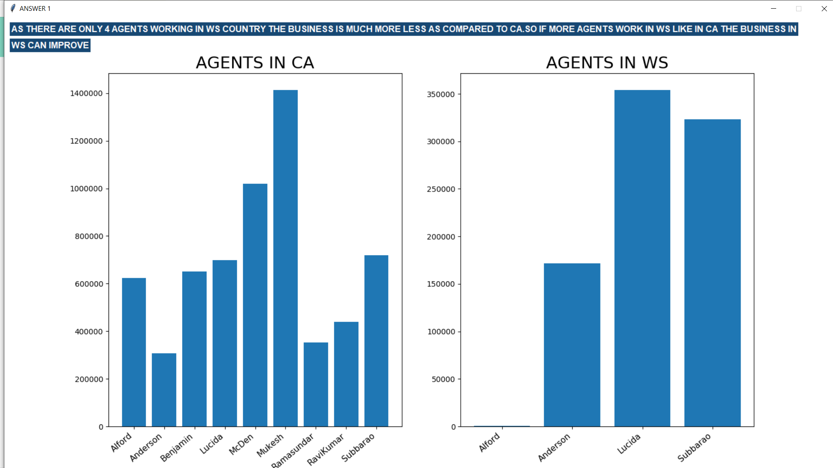

Section 5 :

COMPANY VALIDATION:

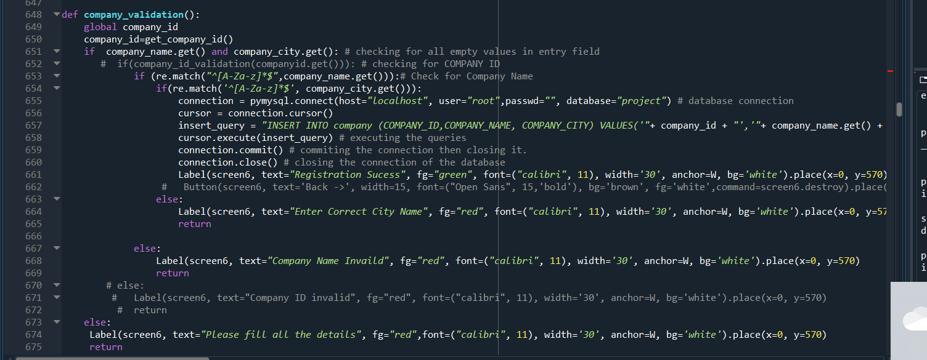

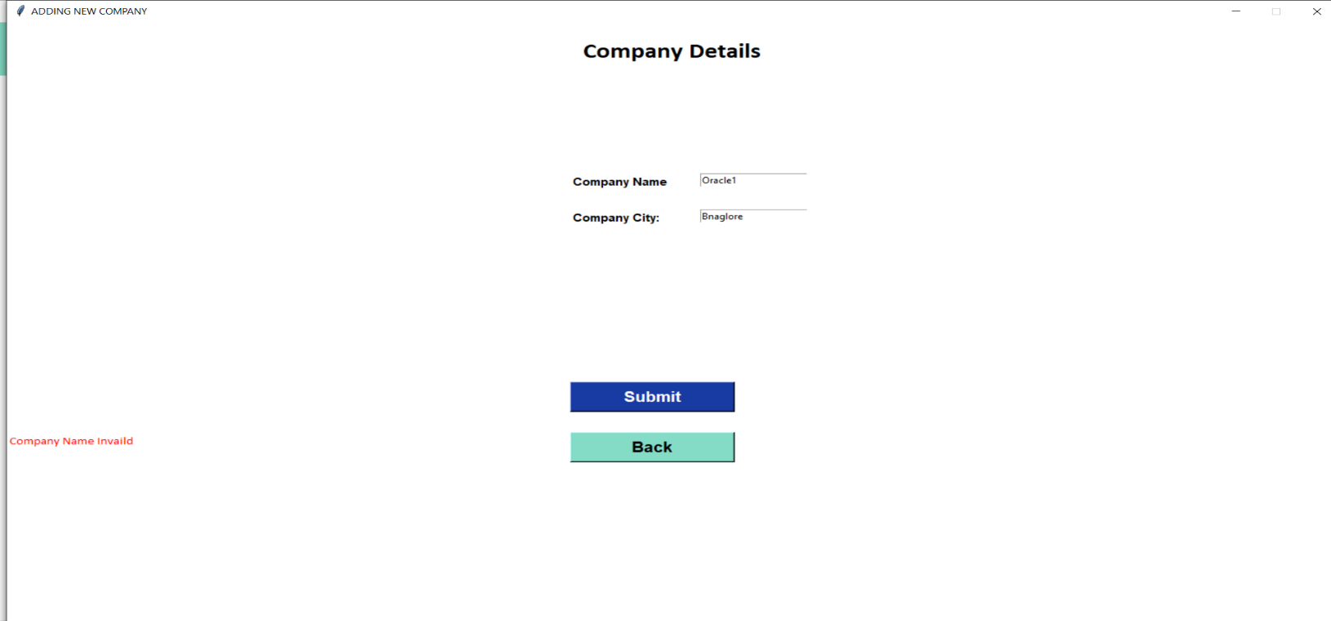

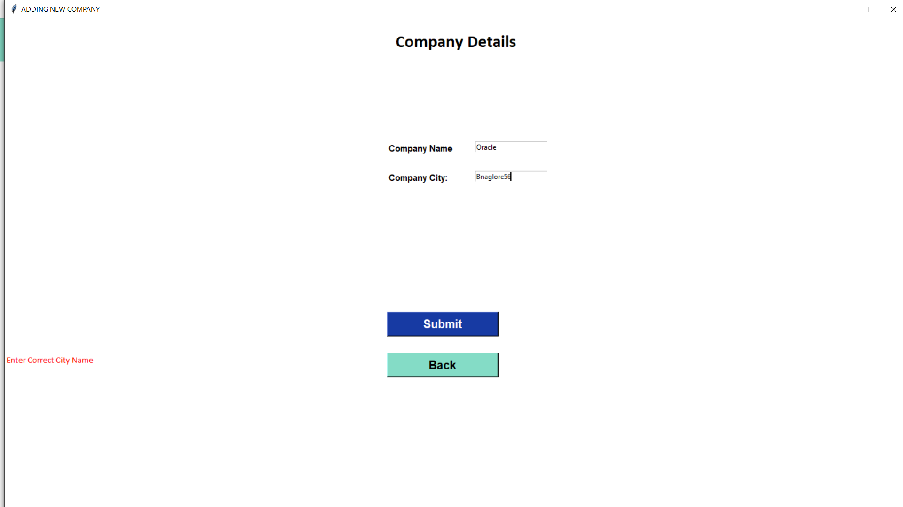

ORDER VALIDATION:

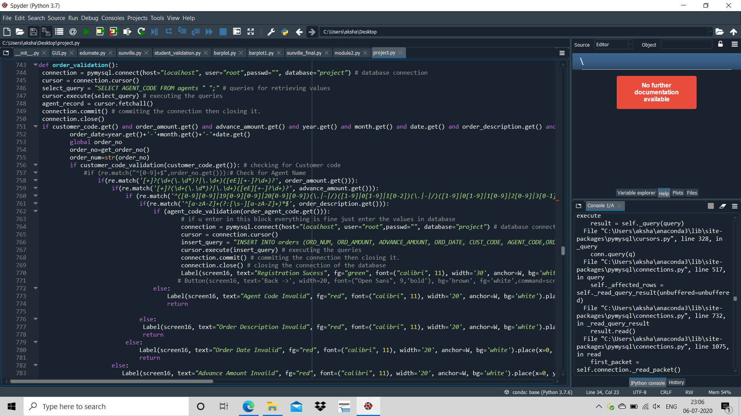

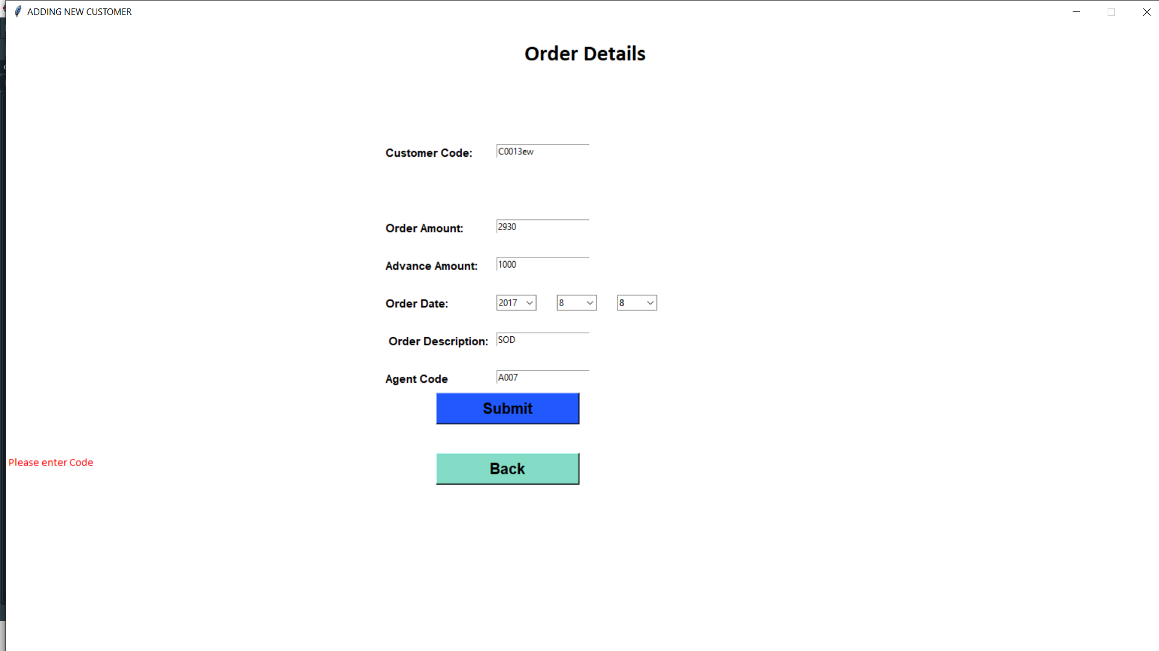

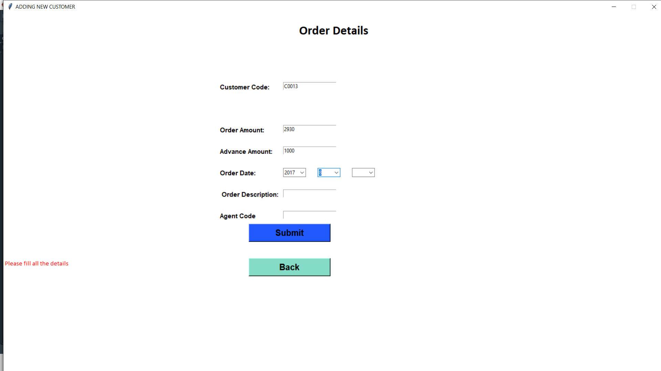

CUSTOMER VALIDATION:

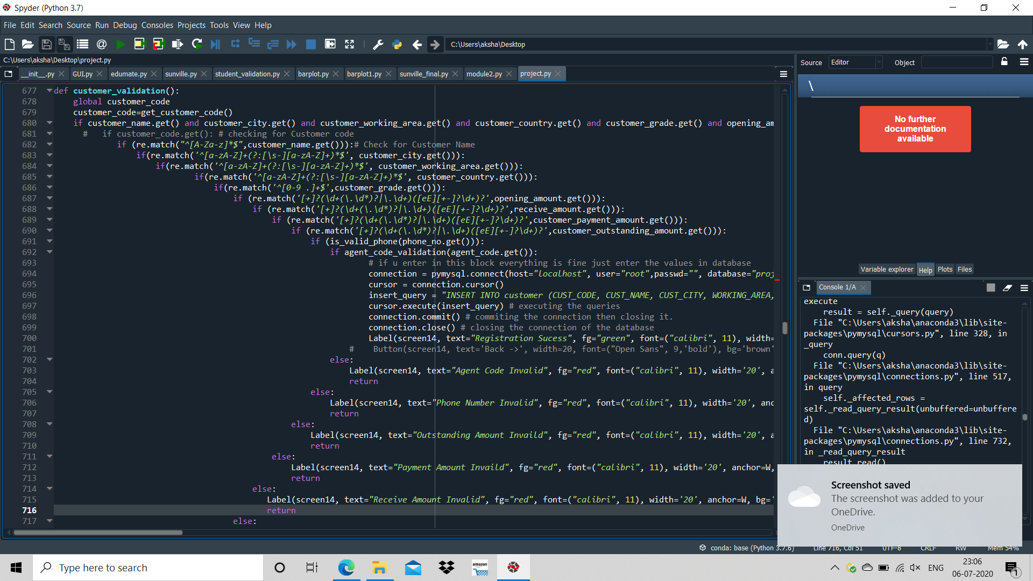

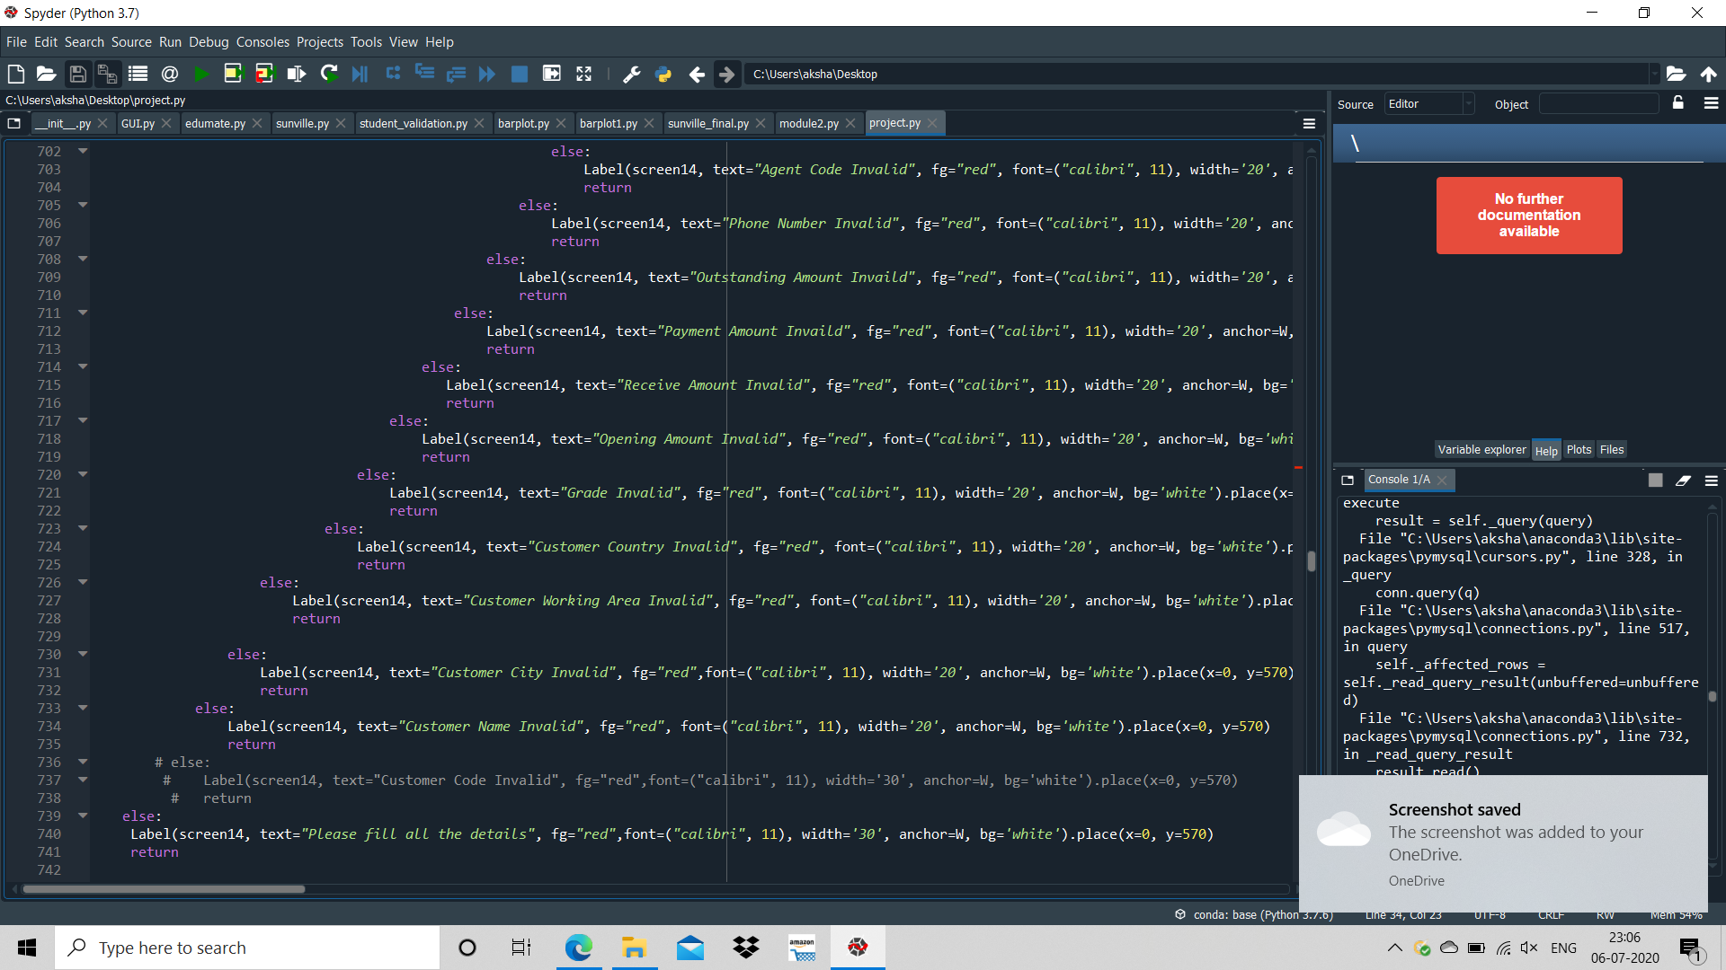

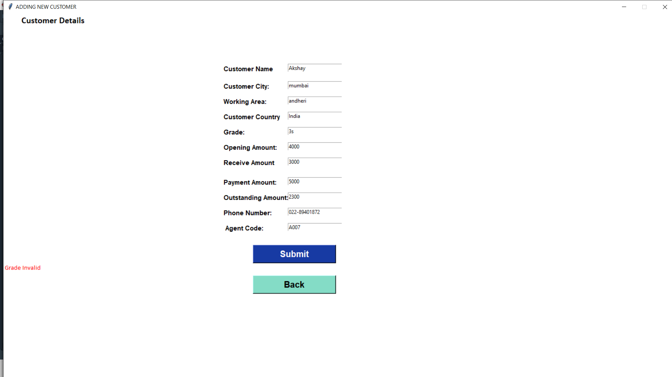

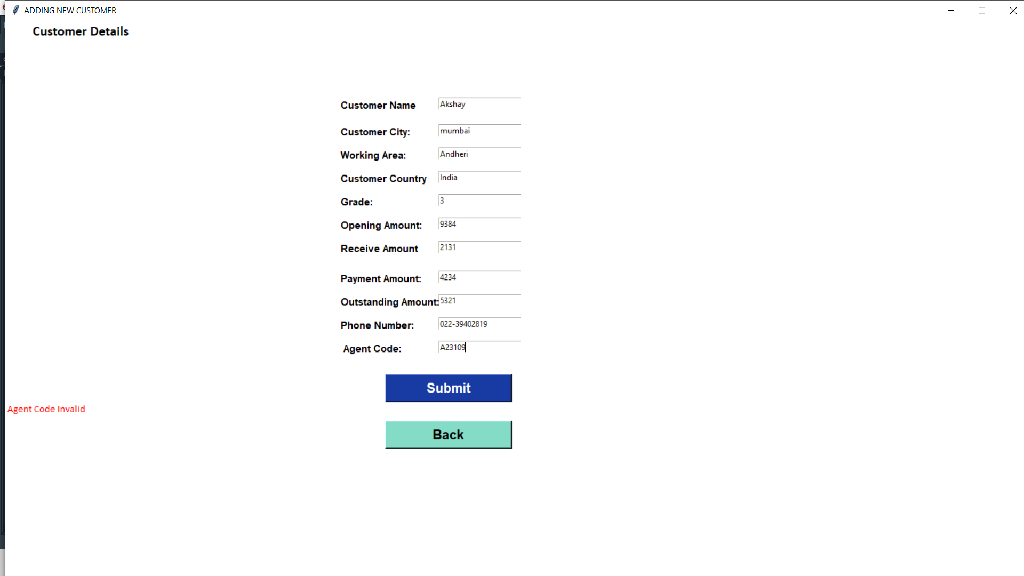

AGENT VALIDATION:

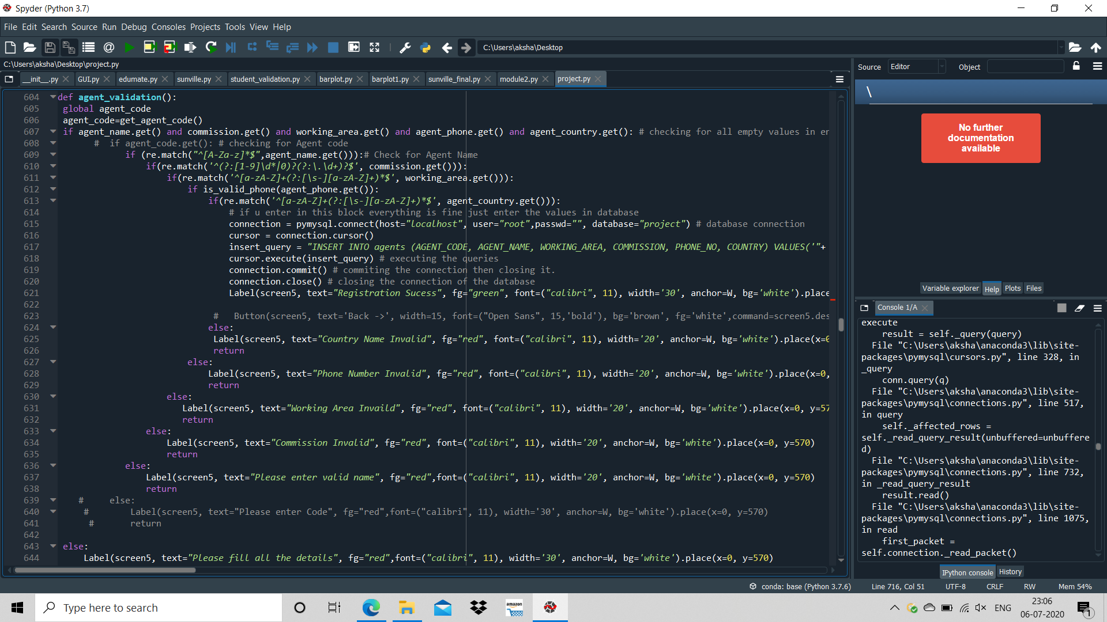

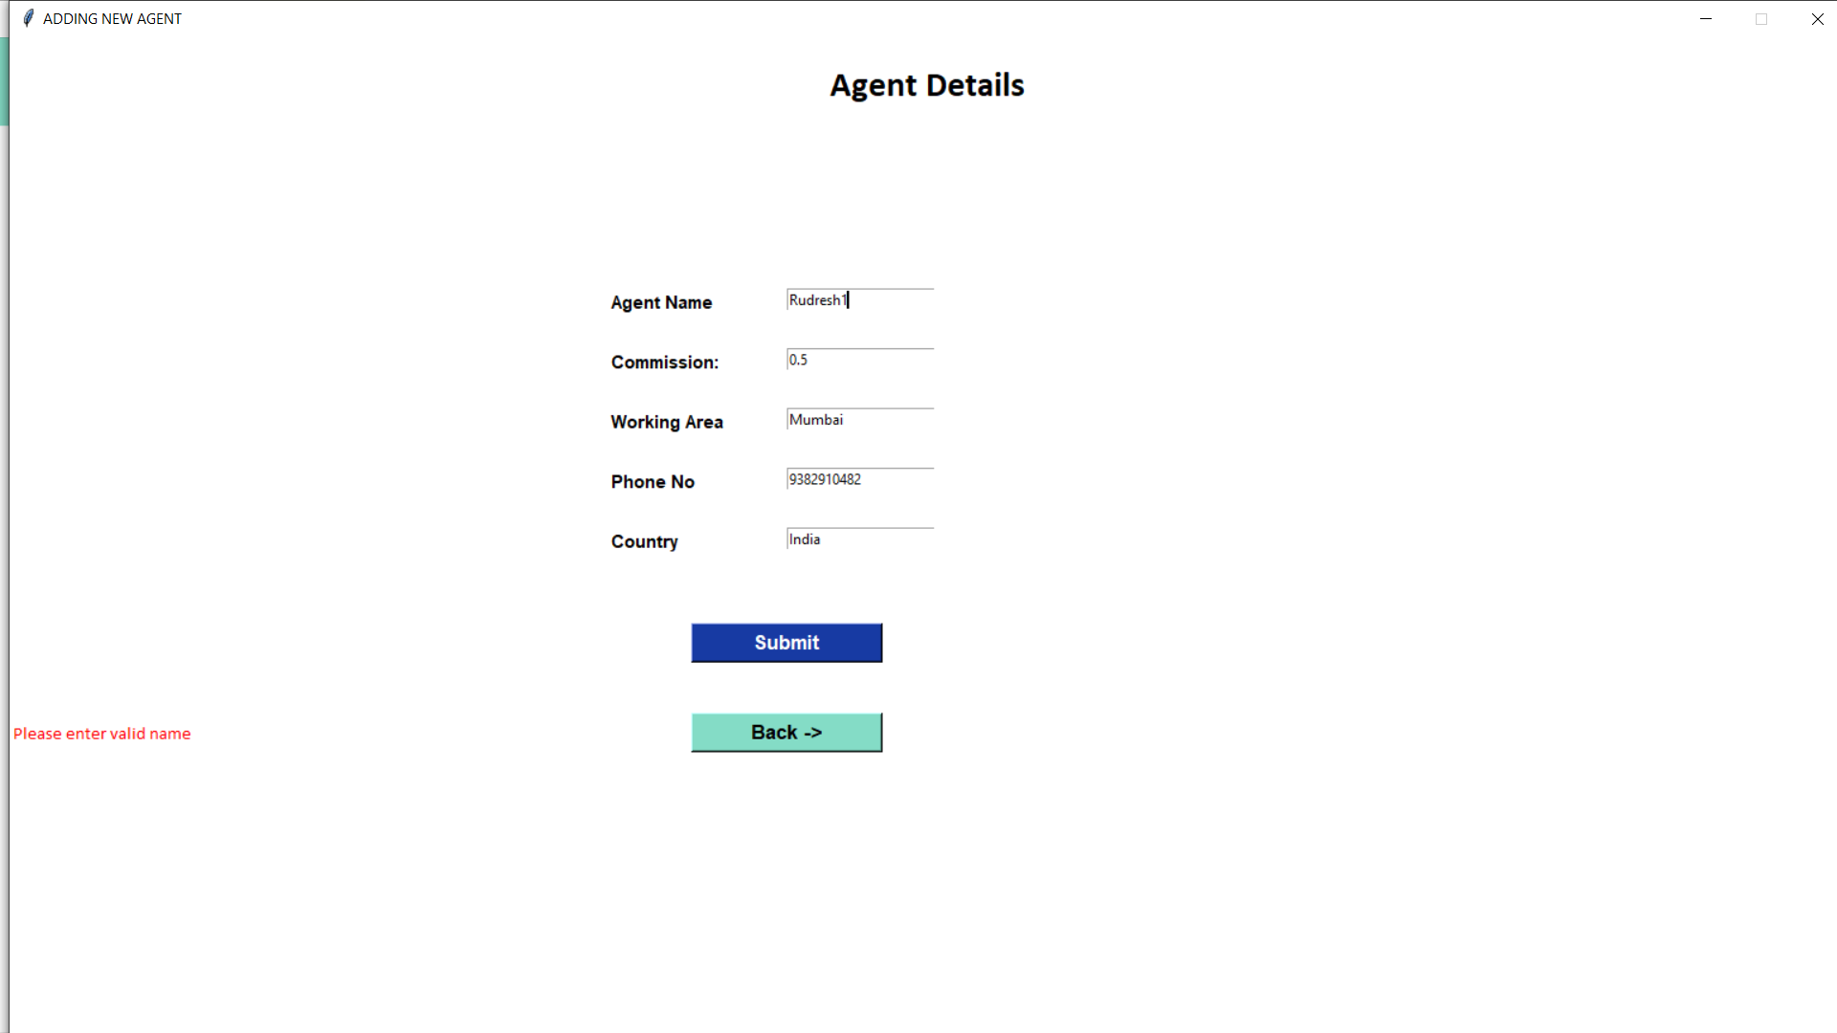

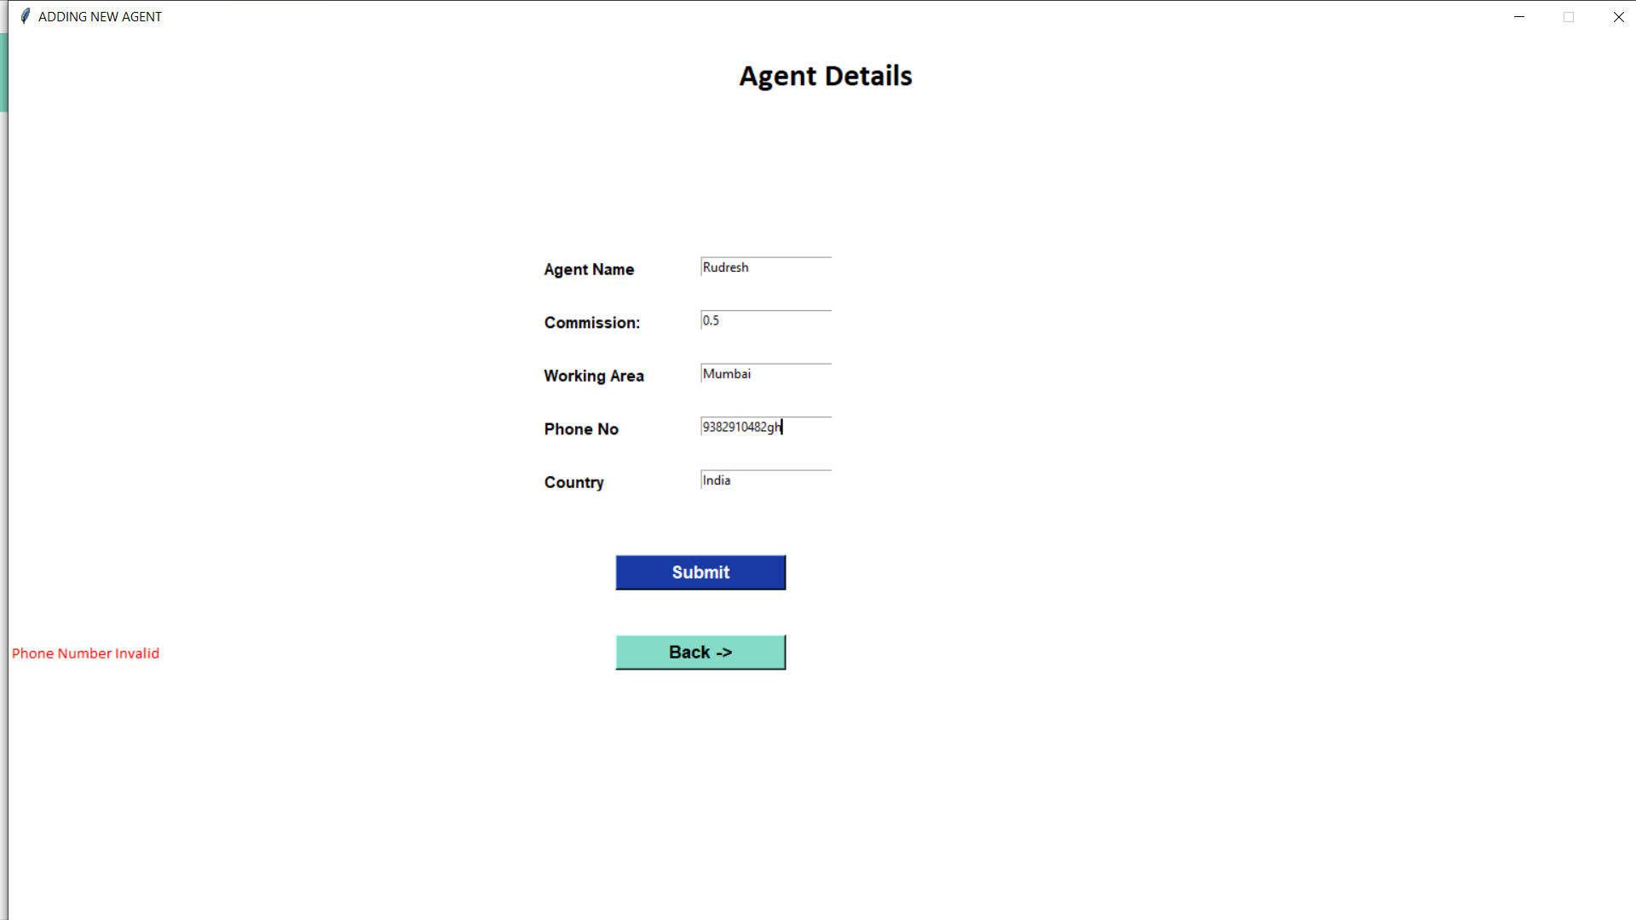

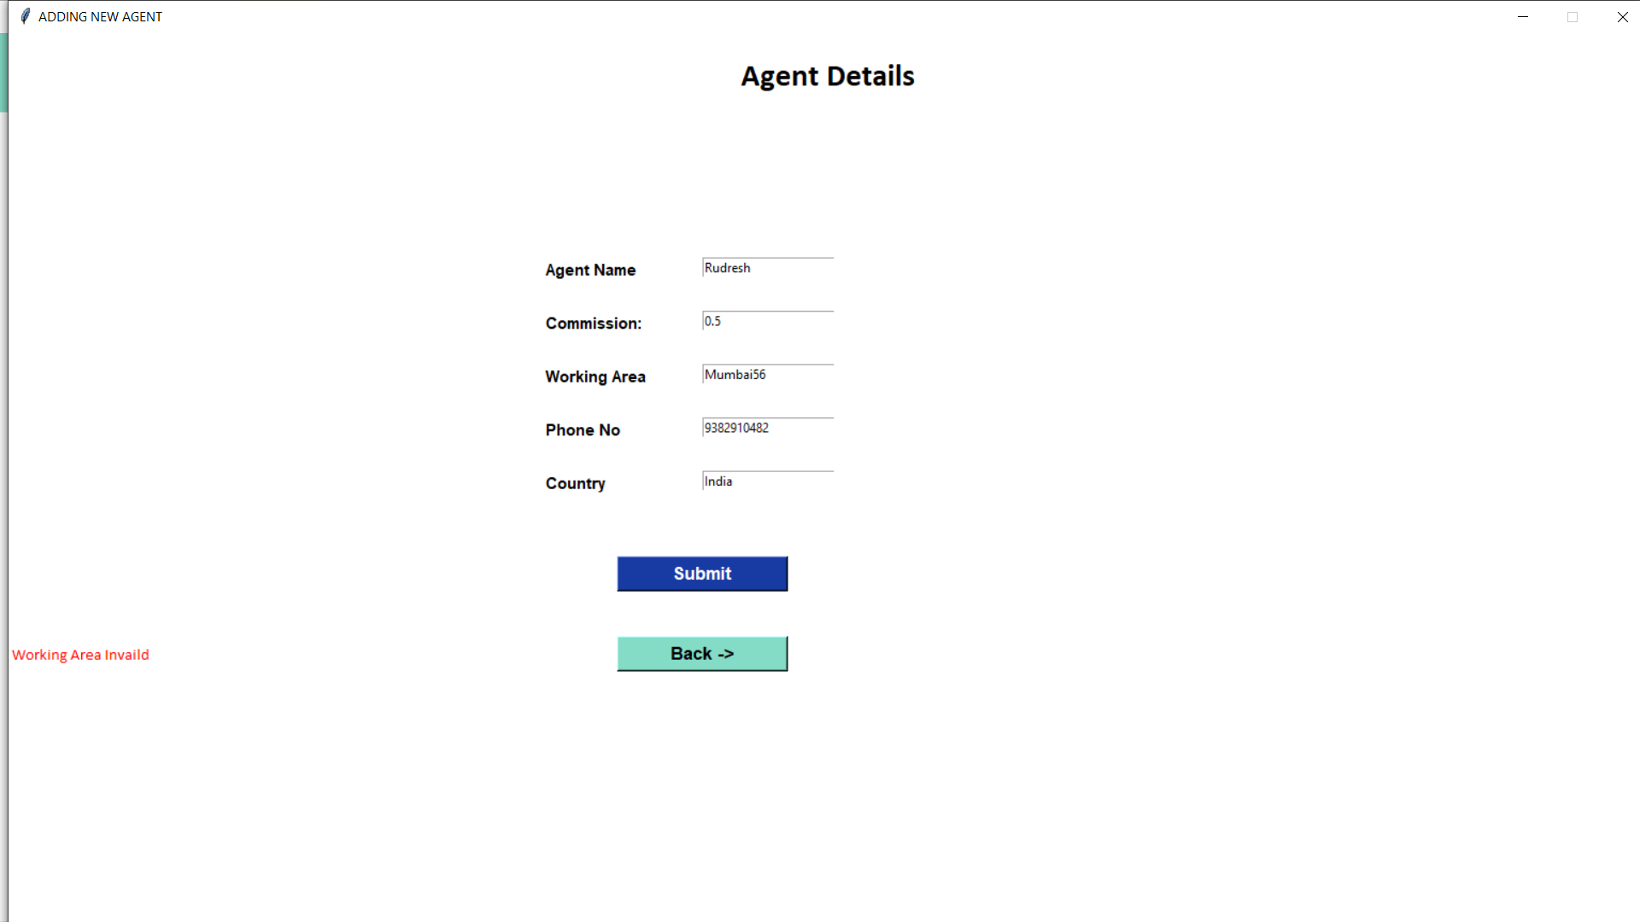

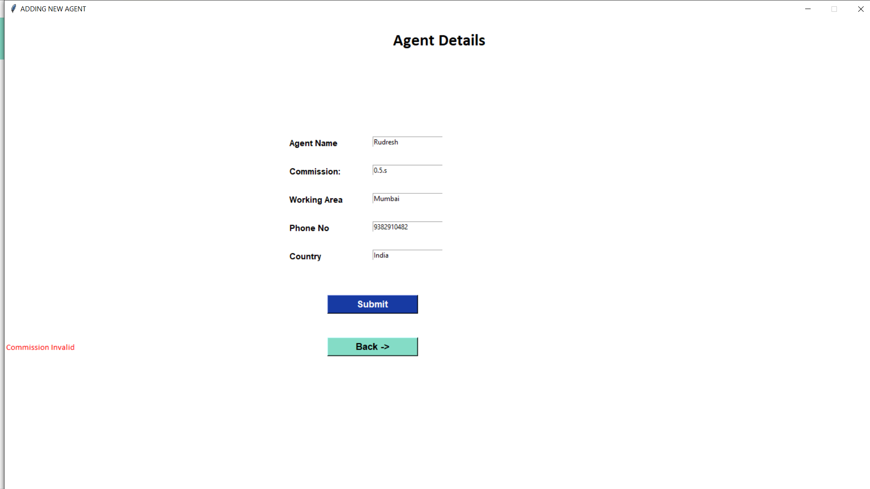

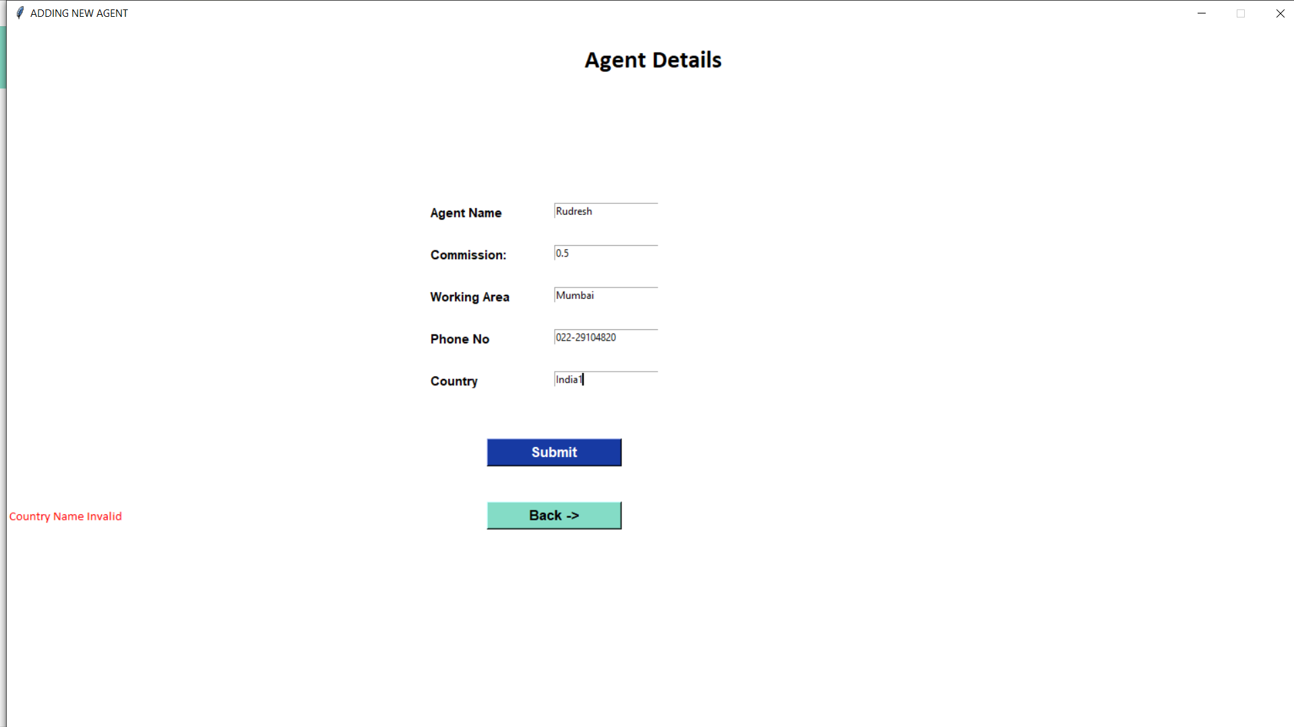

ORDER LOOK-UP

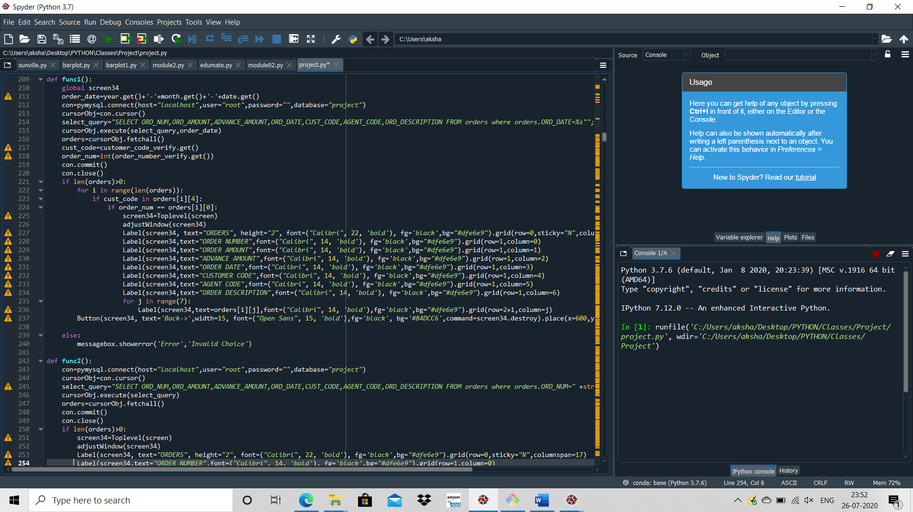

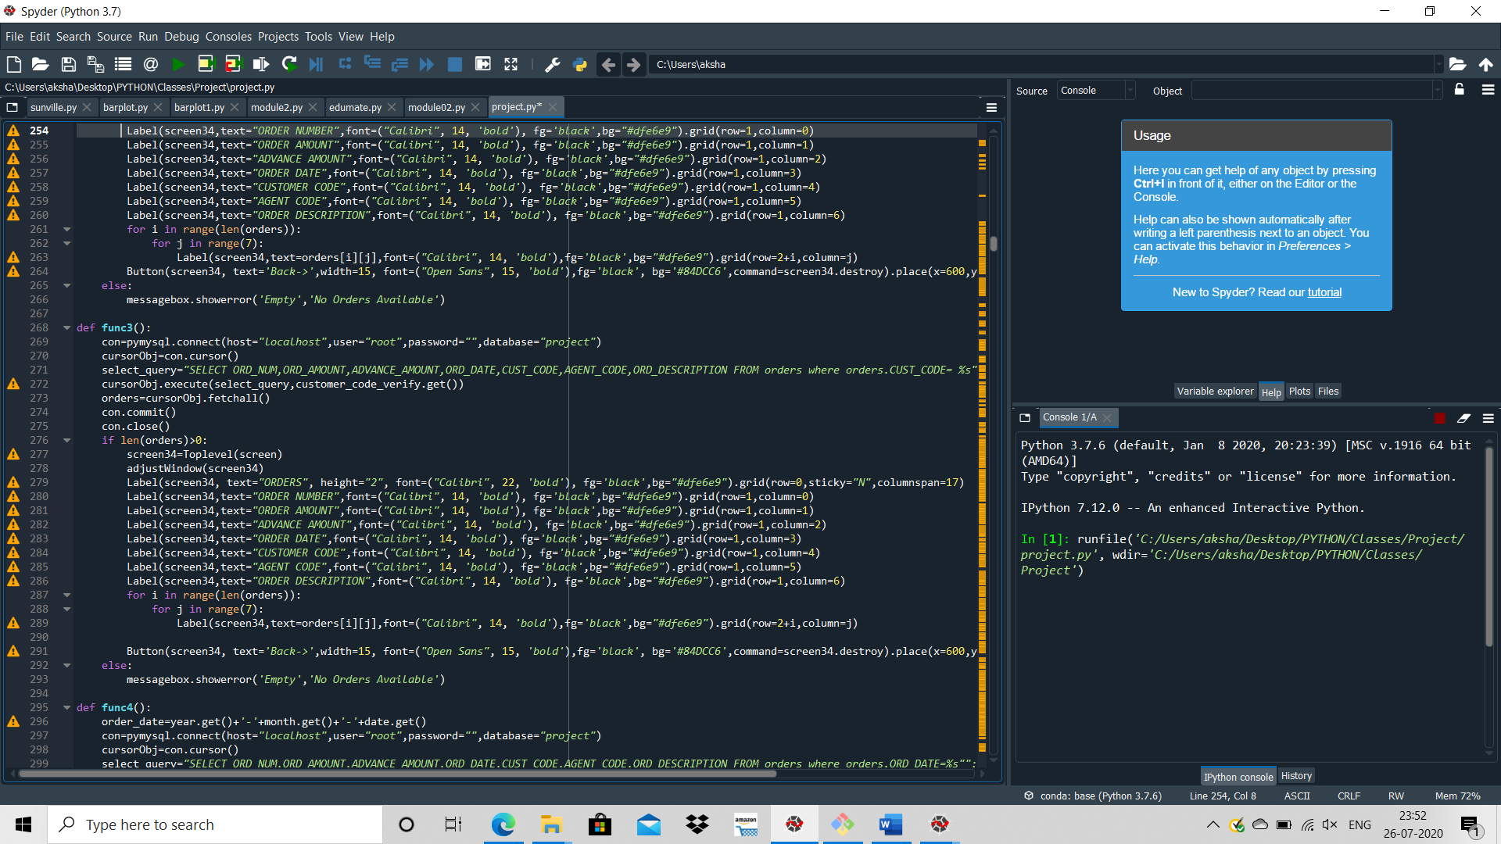

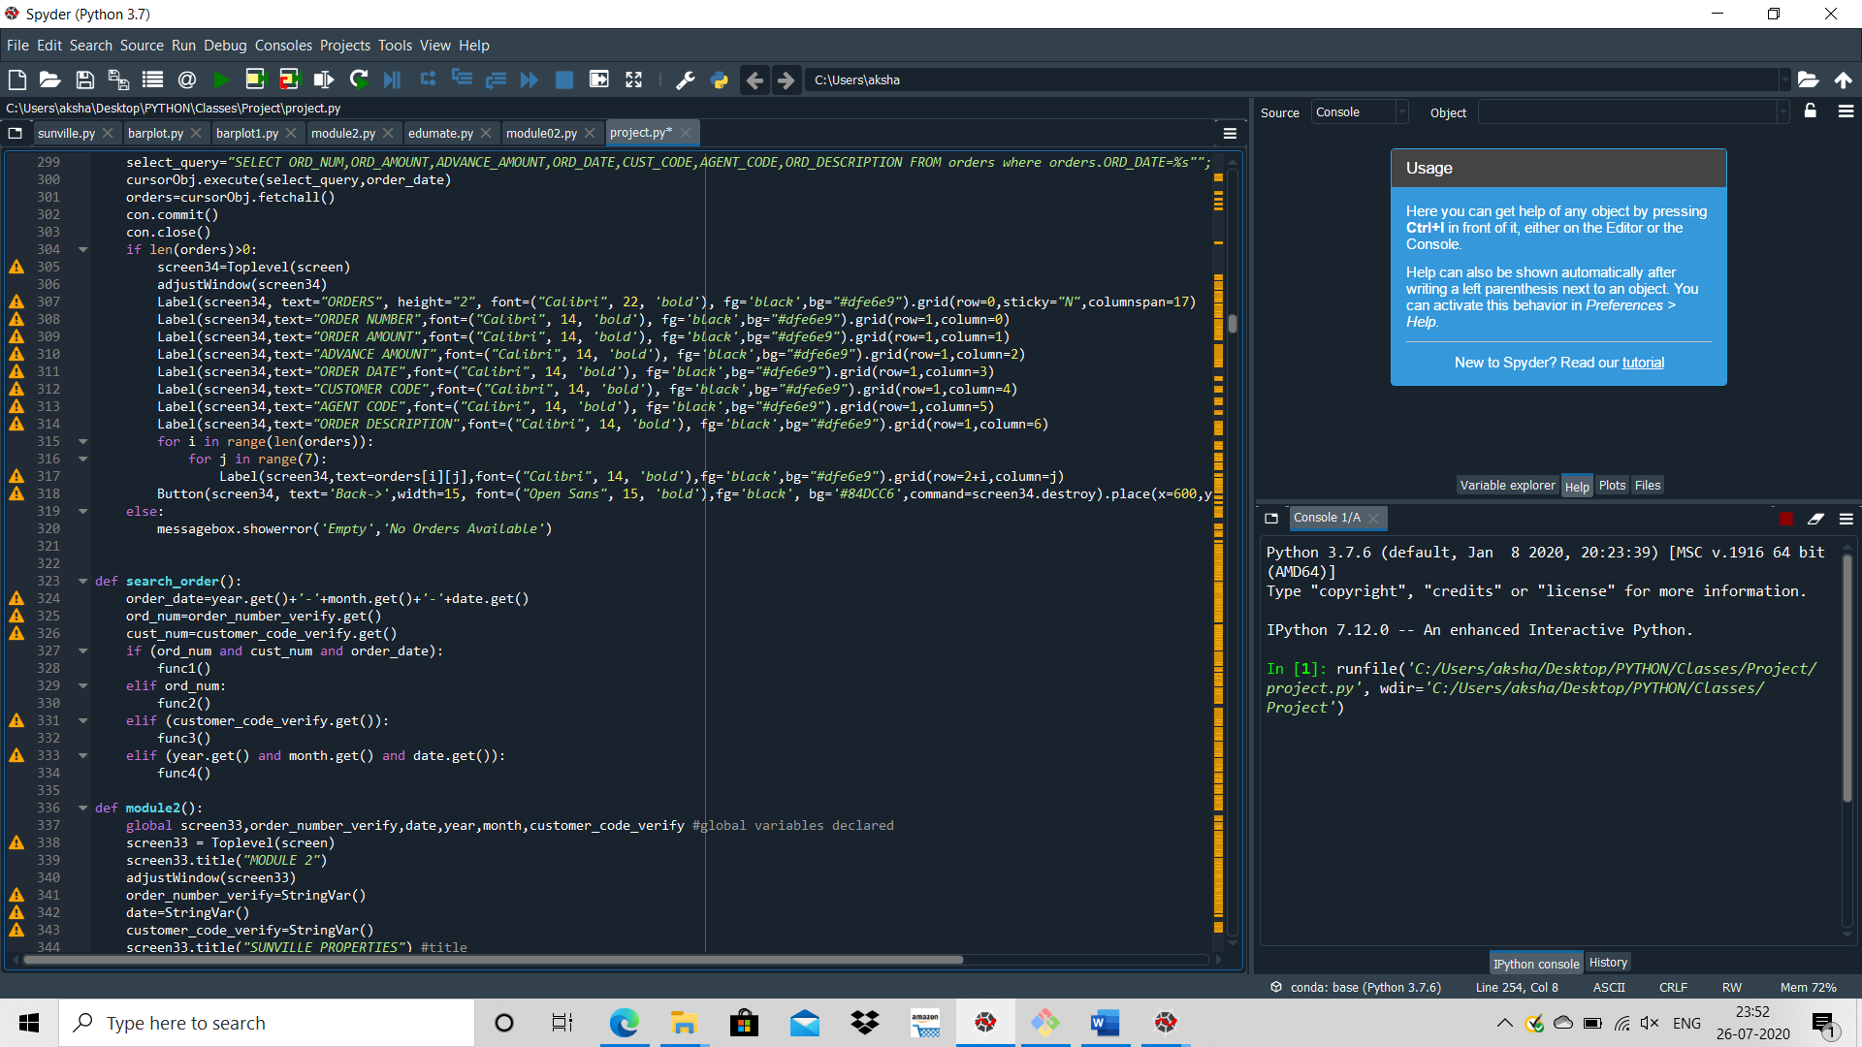

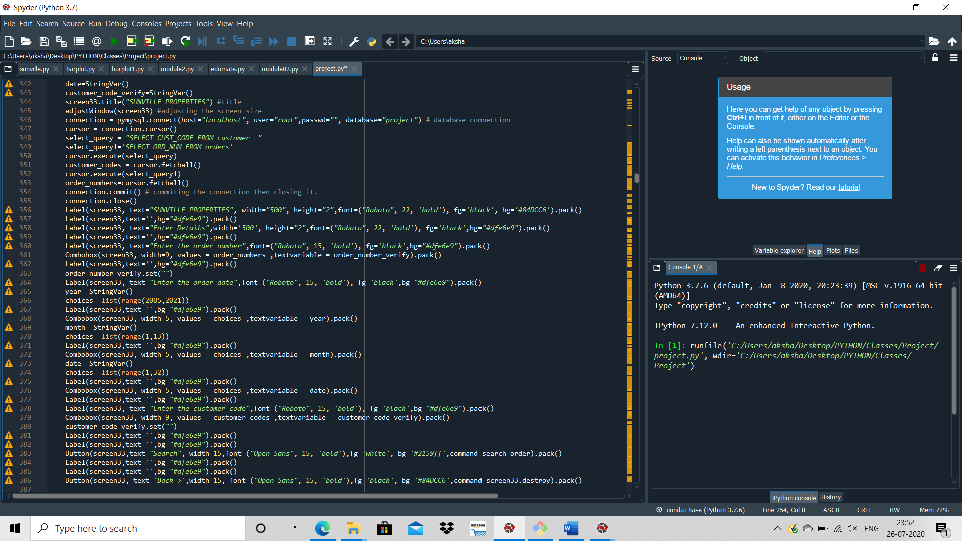

ENTER DETAILS:

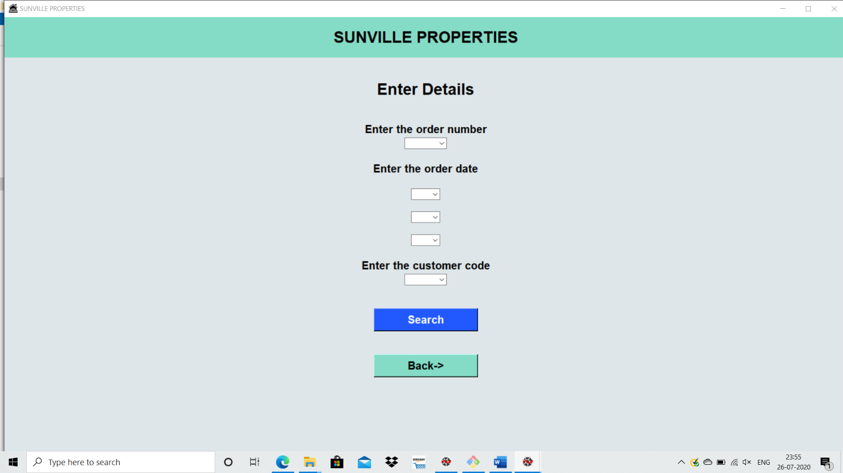

ORDERS BASED ON ORDER NUMBER:

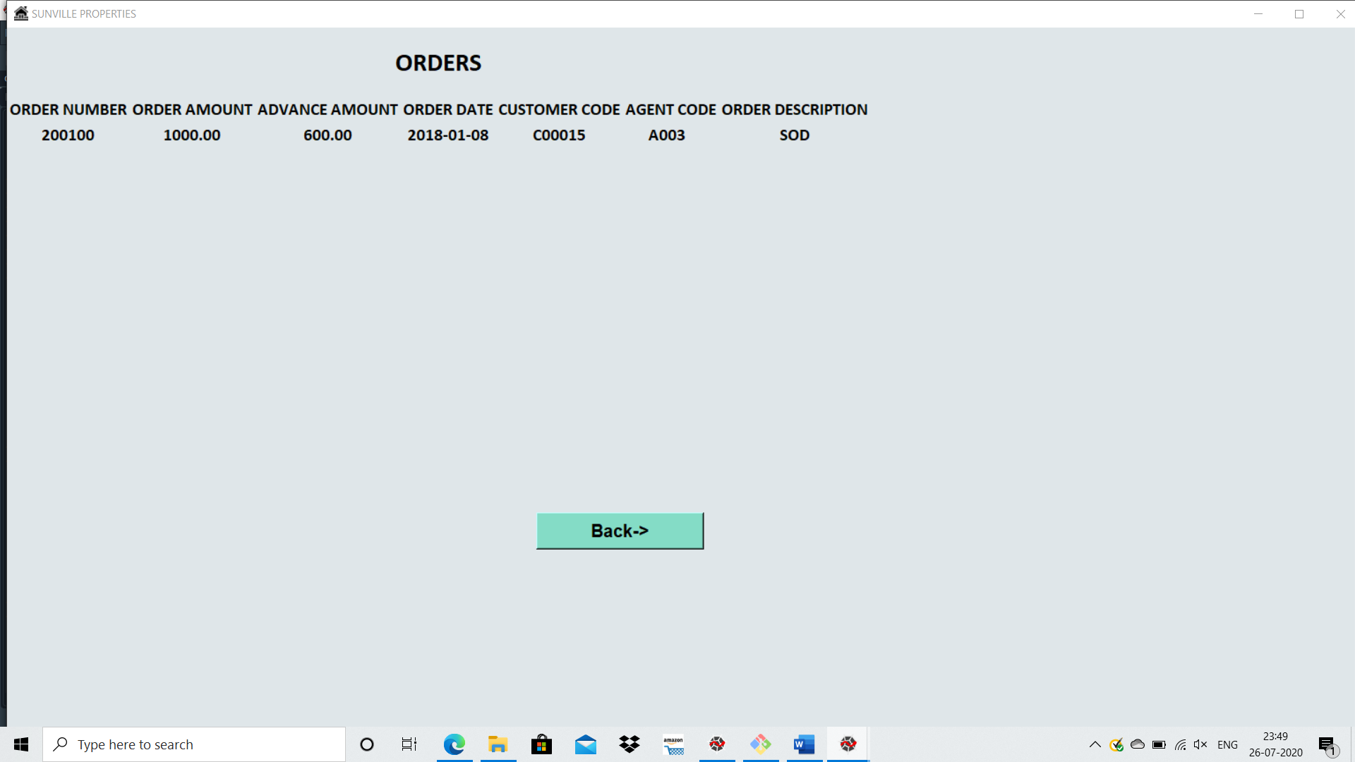

ORDERS BASED ON CUSTOMER CODE:

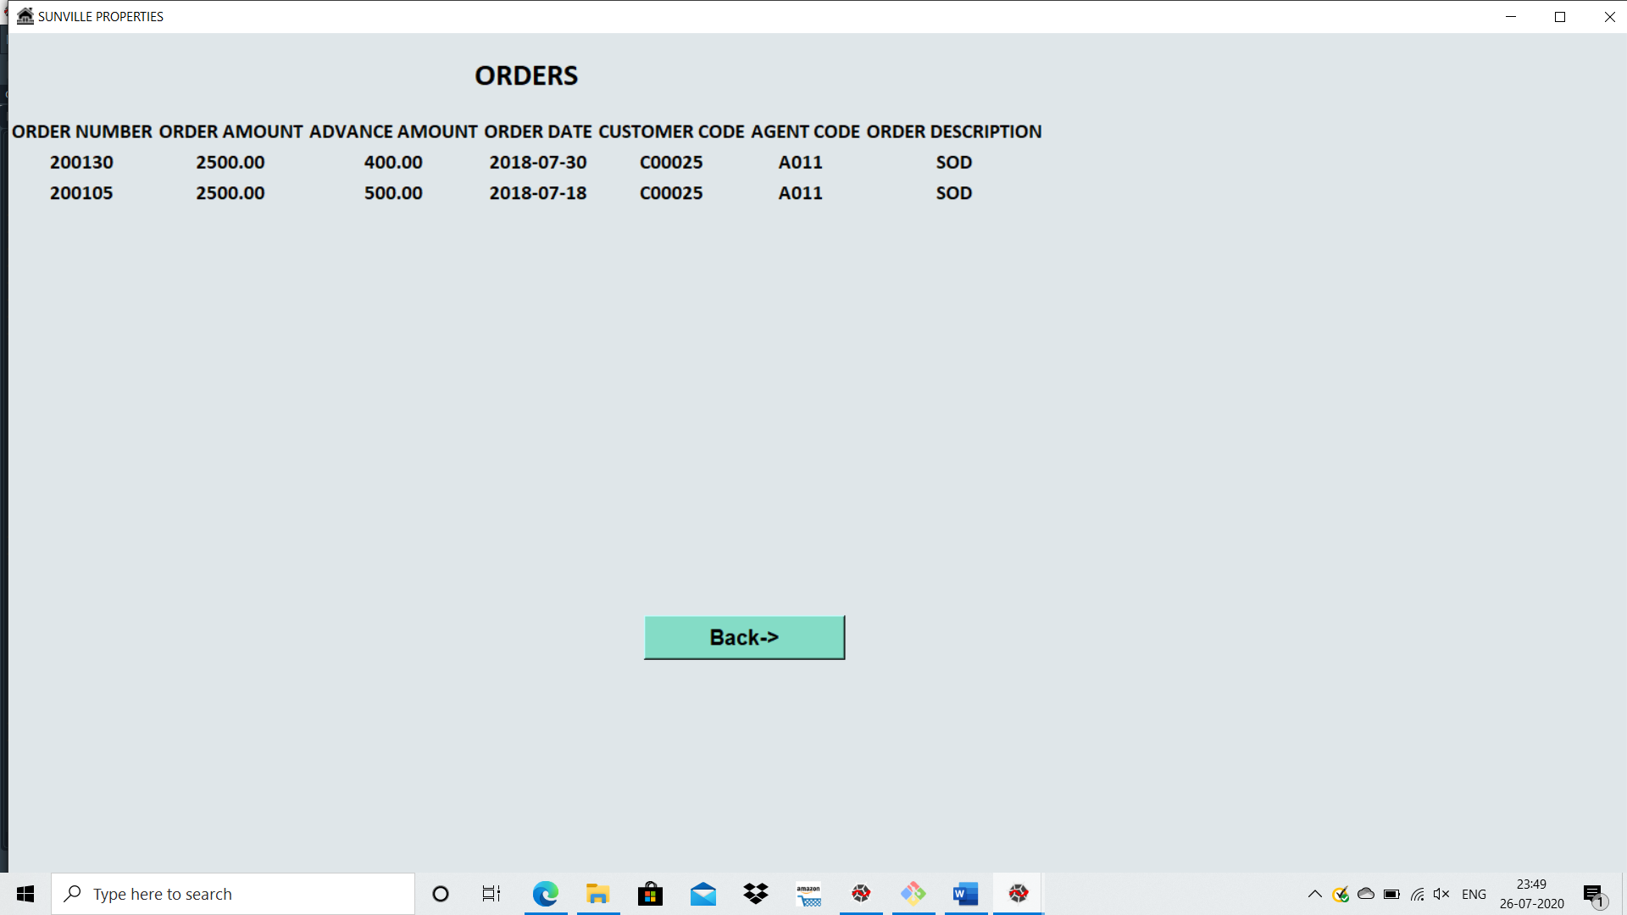

ORDERS BASED ON ORDER DATE:

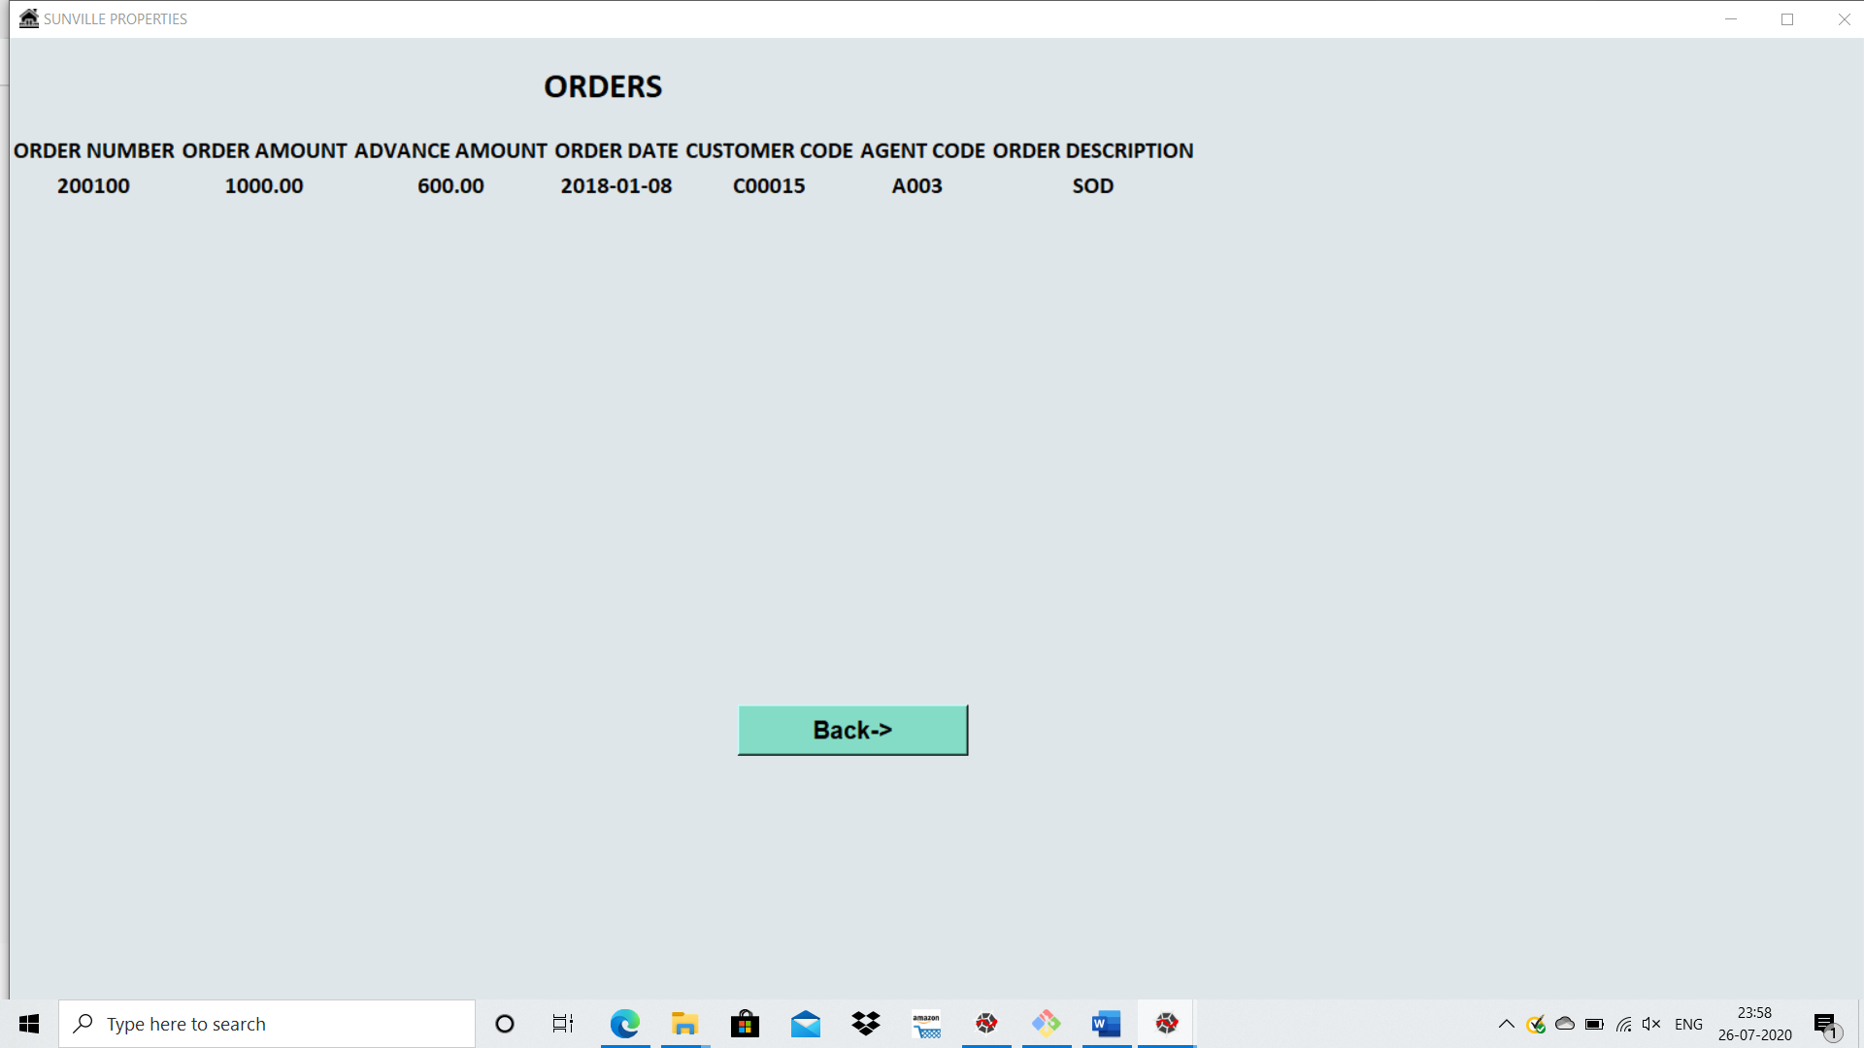

ORDERS BASED ON SELECTION OF ALL DETAILS:

